

**APAMAN**

**Software Requirement Specification**

– Hanoi, February 2023 –

**Record of changeS**

| **Date** | **A* M, D** | **In charge** | **Change Description** |
| --- | --- | --- | --- |
|  |  |  |  |
|  |  |  |  |
|  |  |  |  |
|  |  |  |  |
|  |  |  |  |
|  |  |  |  |
|  |  |  |  |
|  |  |  |  |
|  |  |  |  |
|  |  |  |  |
|  |  |  |  |
|  |  |  |  |

*A - Added M - Modified D - Deleted

**Table of Contents**

I. Overview **5**

1. Introduction 5

2. System Functions 6

a. Screen Flow 6

b. Screen Details 7

c. User Authorization 8

d. Non-Screen Functions 8

3. Entity Relationship Diagram 8

II. Functional Requirements **10**

1. Feature “Authentication User” 10

1.1. Login 10

1.2. Forgot Password 12

2. Manage Account Function

2.1. Add one account for host Apartment

2.2. View list apartment

14

# I. Overview

## 1. Introduction

Currently, many motels for rent still use pen and paper to manage data. For example, the management of electricity, water, vehicles, etc. by checking and recording it on paper. This is outdated and has many disadvantages such as: cumbersome and untidy management, more time and expense, possibly lost documents, etc. So, we thought of developing an apartment management system to streamline and make management easier.

Construction inn management system to manage all the data of tenants and people working at the inn, in addition, has a user-friendly interface that makes it easier for managers as well as tenants. easier access to the inn's services.

- Guests: can view rooms, room status, inn services available,

- Tenants: Provided with an account to manage personal data as well as have reports or check electricity and water numbers, etc.

- Staff: Provided with an account to update inn data and easily manage and handle problems.

- Admin: The owner has full authority to handle the above issues and view the reports and statistics of the inn.

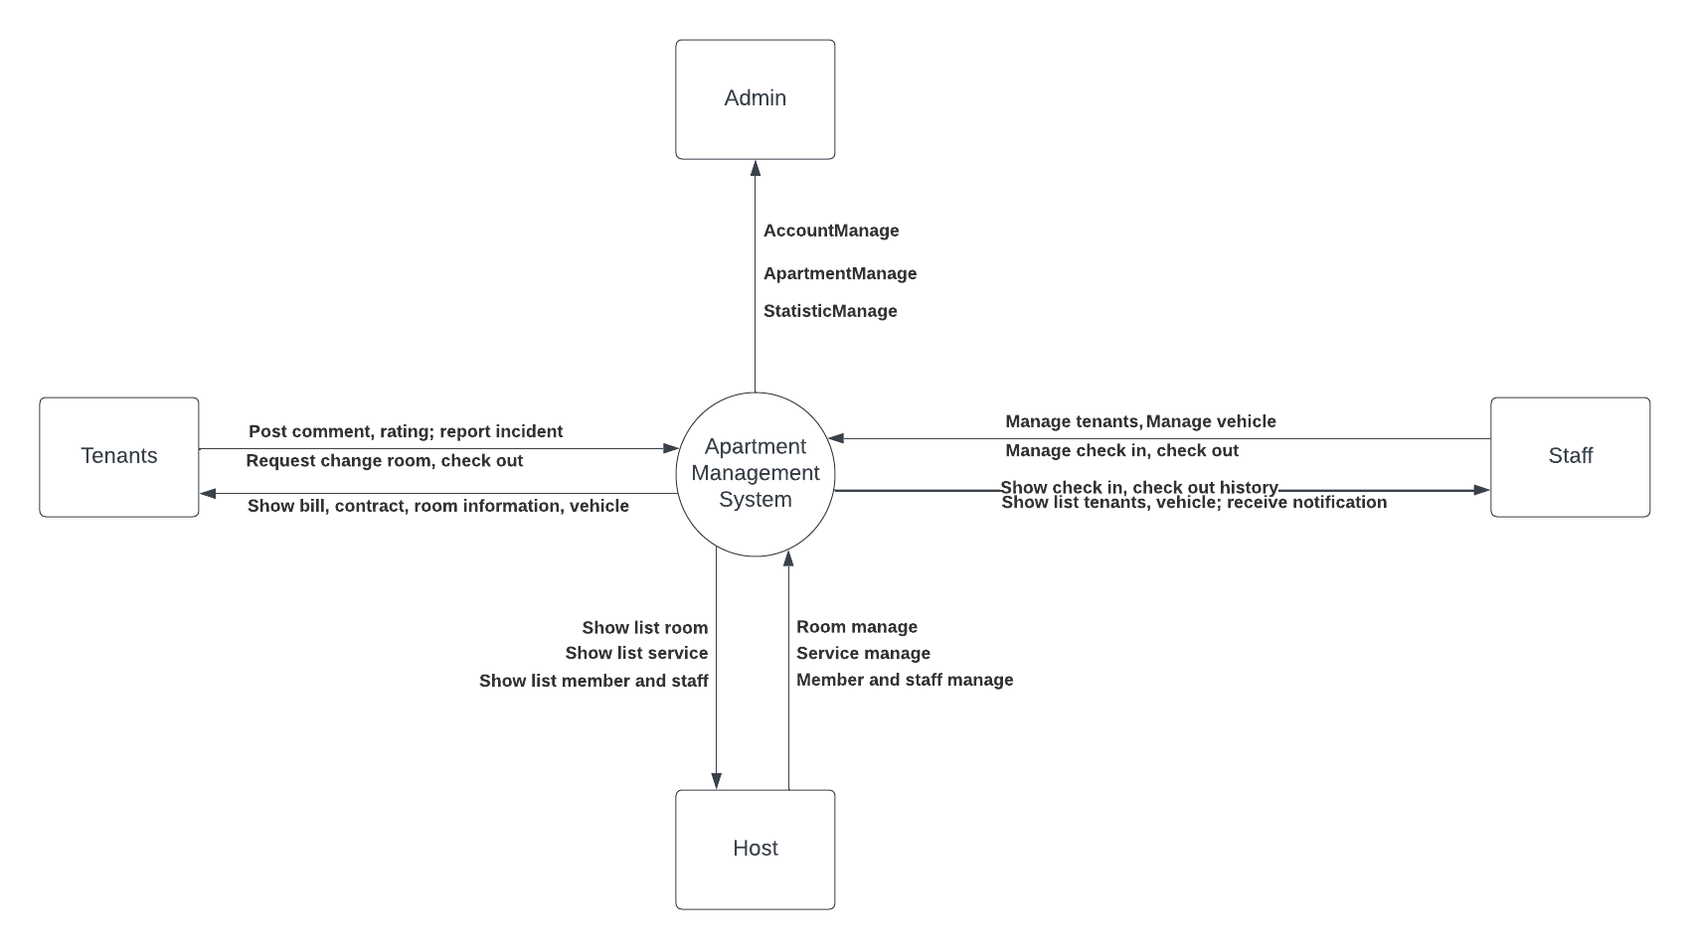

### 

## 

## 

## 

## 

## 

## 

## 

## 2. System Functions

#### a. Screen Flow

##### 1 . Luồng screen Host

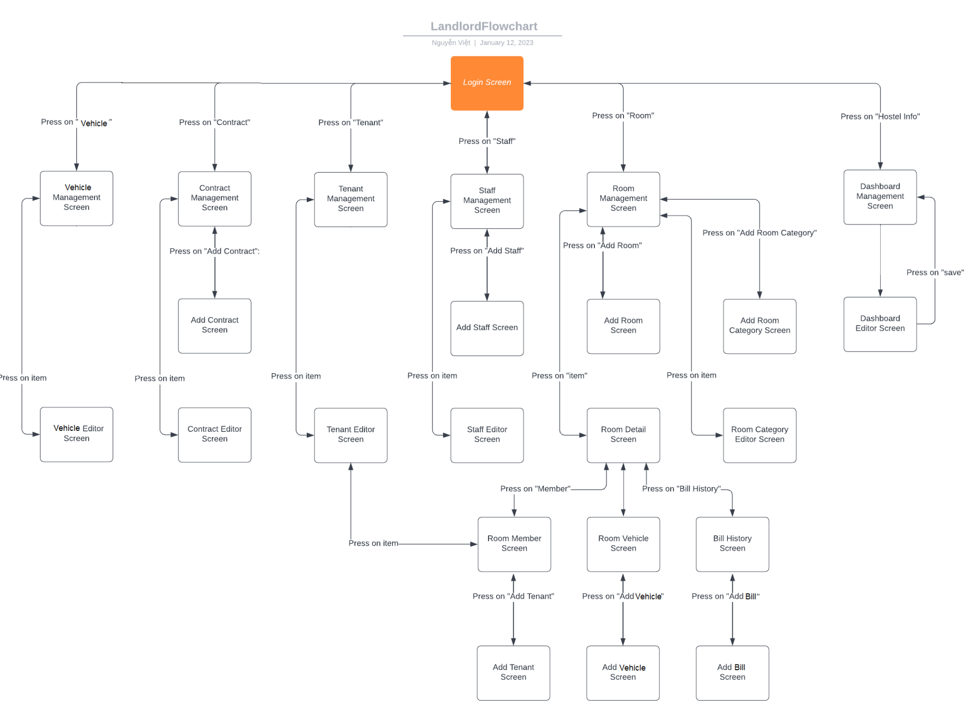

##### 2 . Luồng screen Admin

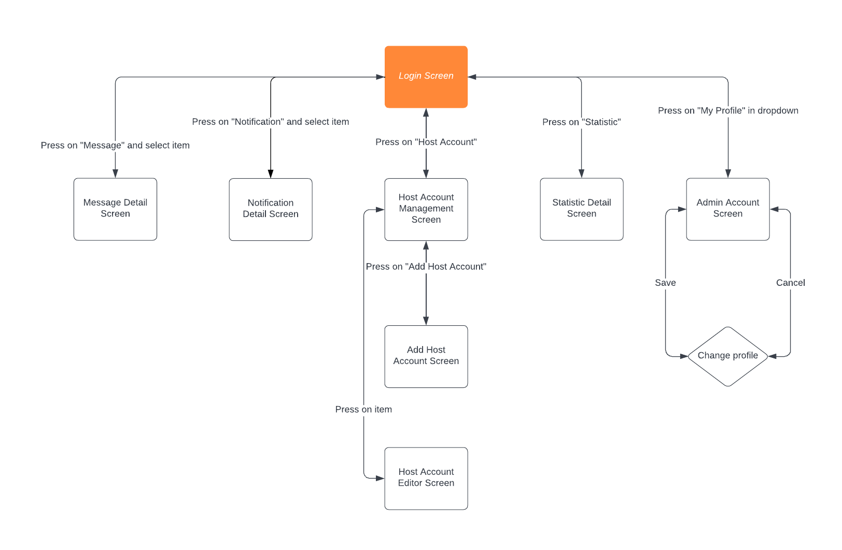

##### 3. Luồng screen Tenant

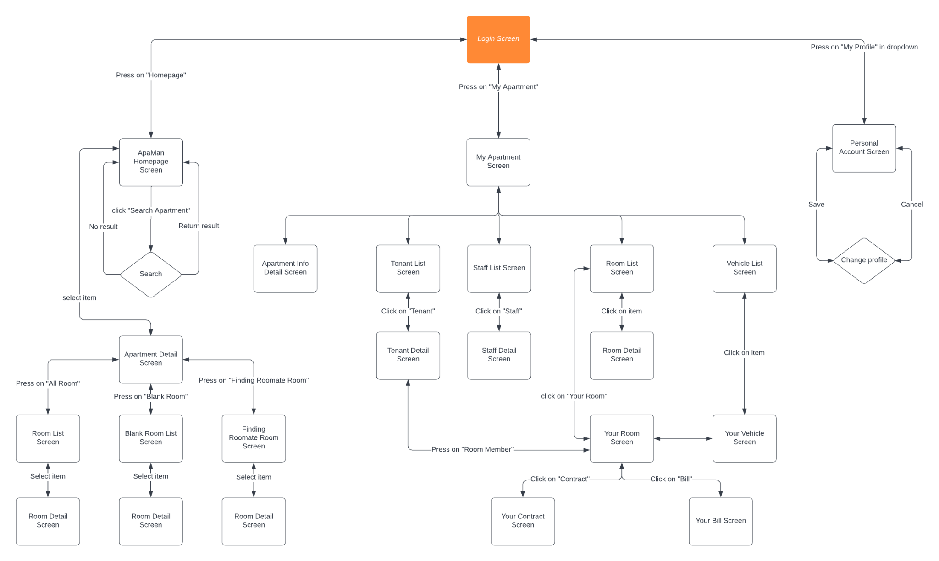

##### 4.Luồng screen Staff

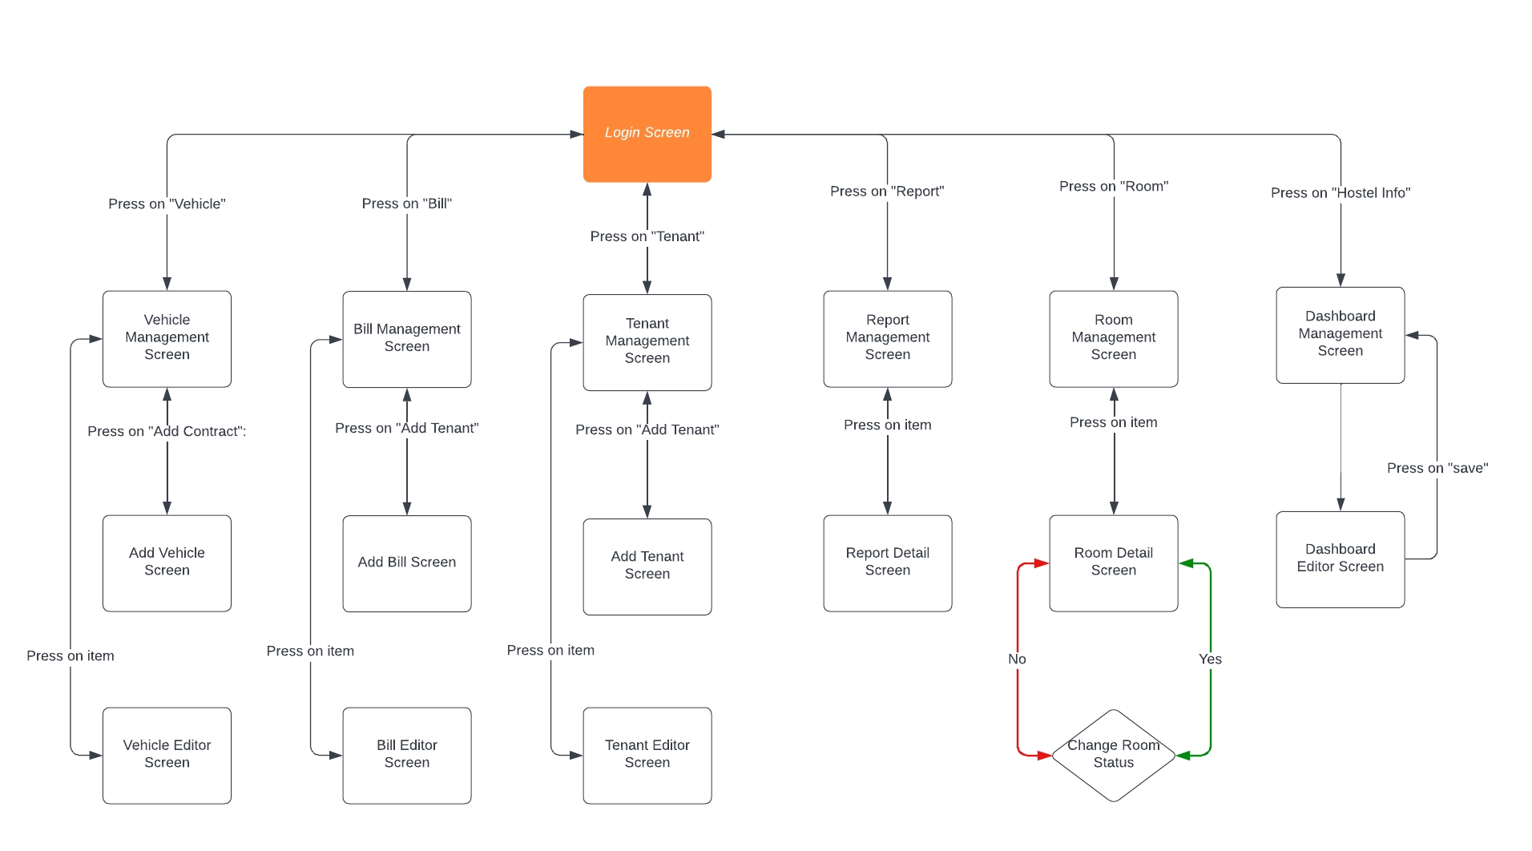

#### b. Screen Details

| **#** | **Feature** | **Screen** | **Description** |
| --- | --- | --- | --- |
| 1 |  |  |  |
| 2 | Authentication & Authorization | Login | This screen allows the user login into the system |
| 3 | Authentication & Authorization | Forgot password | This screen allows the user to enter the email to get the validated code. |
| 4 | Authentication & Authorization | Change Password | After verifying the validated code, this screen allows the user to change the password. |
| 5 | ManageRoom | Edit Room | This screen allows the host to add and edit the rooms in the system. |
| 6 | ManageRoom | Edit Room Type | This screen allows the host to add and edit the room types in the system. |
| 7 | ManageRoom | Edit Floor | This screen allows the host to add and edit the floor in the system. |
| 8 | ManageRoom | Edit Staff | This screen allows the host to add and edit the staff information in the system. |
| 9 | ManageMember | Edit Tenant | This screen allows the host to add and edit the tenant information in the system. |
| 10 | ManageRoom | View List Room | This screen allows the tenant to view all the rooms of the apartment. |
| 11 | ManageStaff | View List Staff | This screen allows the tenant to view all the staff of the apartment. |
| 12 | ManagePayment | View List Bill | This screen allows the tenant to view all the bills of their rooms. |
| 13 | ManagePayment | View Contract | This screen allows the tenant to view their contract with the apartment. |
| 14 | ManageMember | View List Tenant | This screen allows the tenant to view other tenants of the apartment. |
| 15 | ManageMember | View List Vehicle | This screen allows the tenant to view all of the vehicles in the apartment. |
| 16 | ManageMember | Edit Vehicle | This screen allows the host and staff to add and edit the vehicle's information in the system. |
| 17 | ManageApartment | Edit HomePage | This screen allows the host and staff to edit the apartment information in the homepage. |
| 18 | ManageApartment | View Statistic | This screen allows the host to view the apartment information’s statistics in the system. |

#### c. User Authorization

| **Screen** | **Guest** | **Tenants** | **Admin** | **Staff** | **Host** |
| --- | --- | --- | --- | --- | --- |
| Login |  | x | x | x | x |
| Forgot password |  |  |  |  | x |
| ManageAccount |  |  | x |  | x |
| Edit personal profile |  |  | x |  | x |
| Change password |  |  | x |  | x |
| List of Apartment | x | x | x | x | x |
| Filter search apartment | x | x | x | x | x |
| List of Room | x | x | x | x | x |
| List of Tenant |  | x | x | x | x |
| List of Vehicle |  |  | x | x | x |
| List of Bill |  |  |  | x | x |
| Bill Detail |  | x |  | x | x |
| Request Change Room |  | x |  |  |  |
| Request Incident |  | x |  |  |  |
| Check-in |  | x |  | x | x |
| Check-out |  | x |  | x | x |
| Notification list |  |  |  | x | x |
| Room Editor |  |  |  |  | x |
| Vehicle Editor |  |  |  |  | x |
| Tenant Editor |  |  |  | x | x |
| Add Tenant |  |  |  | x | x |
| Change Room Status |  | x |  |  | x |
| Add Bill |  |  |  | x | x |
| Add Vehicle |  |  |  | x | x |
| Add Room |  |  |  |  | x |
| System report management |  |  |  | x | x |
| Email verification |  |  |  |  | x |

## 3. Entity Relationship Diagram

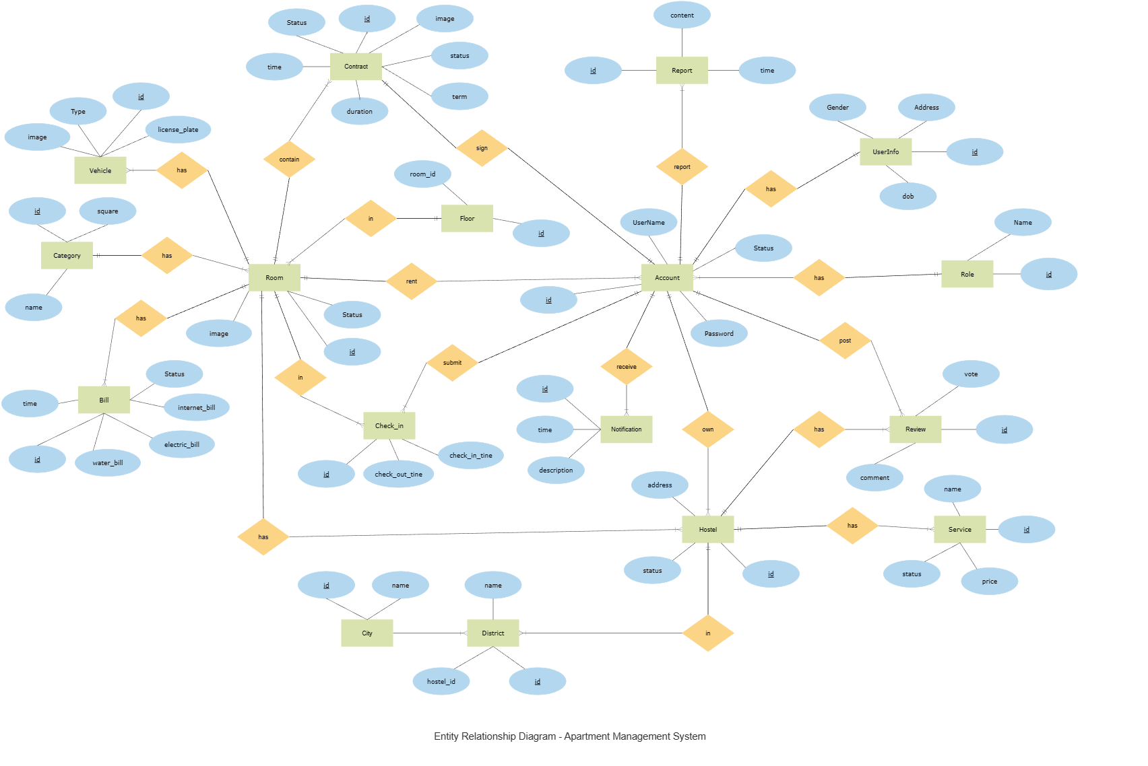

**Entities Description**

| **#** | **Entity** | **Description** |
| --- | --- | --- |
| 1 | Room | Contain room information |
| 2 | Account | For who use the system |
| 3 | Role | A user can have one role only, either normal user or admin. |
| 4 | Member | Contain member information |
| 5 | Notification | Notifications are generated by the system. |
| 6 | Hostel | Contain a hostel information |
| 7 | Bill |  |
| 8 | City | Contains all provinces and cities in Vietnam. |
| 9 | District | Contains all districts of every province and city in Vietnam. |
| 10 | Staff | Constain |
| 11 | Review | Uploaded by a tenant, shown on the apartment homepage. The tenant must have checked-in to upload a review. |
| 12 | Report | Sent by a user to report inappropriate information in the system. |
| 13 | Check-in | Contain information about check-in and check-out time of a tenant in an apartment . |
| 14 | Category | Contains all room category |
| 15 | Contract | Contains contract between tenants and apartment’s host. |
| 16 | Vehicle | Contains all tenant’s vehicle information |
| 17 | Floor | Contains all floor |

# II. Functional Requirements

## 1. Feature1: Authentication

### 1.1. Login Function

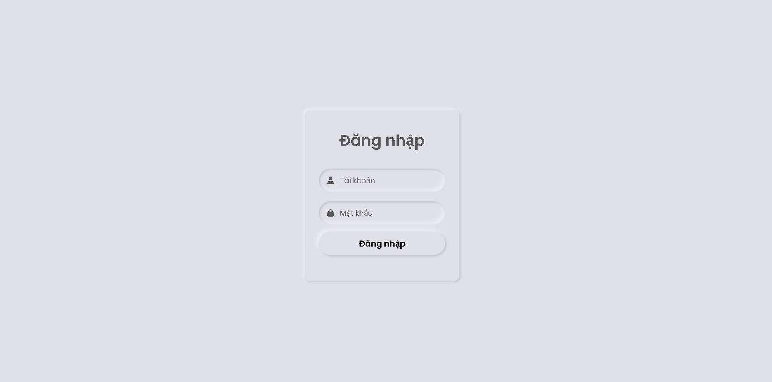

* **Function Trigger** :
  + When actor access to systems
* **Function description :** 
  + Actor/Role : Admin , Staff , Tenant , Host
  + Purpose : Authenticated the account is valid to access to the system or not . If not, show the message .
  + Interface :
* 2 text fields to fill username and password
* 1 link “Forgot password”

| **UC ID and Name:** | **UC-01. Login** | | |
| --- | --- | --- | --- |
| **Created By:** | QuocNQ | **Date Created:** | 11/01/2023 |
| **Primary Actor:** | Tenant, Admin, Landlord, Staff | **Secondary Actors:** | N/A |
| **Trigger:** | N/A | | |
| **Description:** | This use case allows the users to login into the system. | | |
| **Preconditions:** | **PRE-01.** The user has registered an account in the system.  **PRE-02.** The user’s username has not been deactivated in the system. | | |
| **Post-conditions:** | **POST-01.** The system saves the user’s login session. | | |
| **Normal Flow:** | **1.0. Login to the system**  1. The user has access to the system.  2. The system displays the Login screen.  A required text field to input the username.  A required text field to input the user’s password.  3. The user inputs his/her username and password, then presses on the “Login” button to login.  4. The system validates and the user logs in successfully. | | |
| **Alternative Flows:** | N/A | | |
| **Exceptions:** | **1.0.E1. Wrong username or password**  1. In step 3, if the user inputs the wrong username or password.  2. The system rejects the user’s login attempt and displays an error message (MSG01).  **1.0.E2. Leave required fields blank**  1. In step 3, if the user logs in without providing a username or password.  2. The system rejects the user’s login attempt and displays error messages (MSG02).  **1.0.E3.** **The user inputs the wrong password format**  1. The user inputs a password less than 8 characters.  2. The system rejects the user’s attempt and displays an error message (MSG03). | | |
| **Priority:** | High | | |
| **Frequency of Use:** | High | | |
| **Business Rules:** | BR-01, BR-02 | | |
| **Other Information:** | 1. If the user logs out from the system, the system returns to the Homepage | | |
| **Assumptions:** | N/A | | |

| **Description** | The screen will appear if the user has not logged in for the first time |
| --- | --- |
| **Functional requirement** | · Forgot password navigation buttons must be underlined. |

### 1.2. Forgot Password

| **UC ID and Name:** | **UC-03. Forgot password** | | |
| --- | --- | --- | --- |
| **Created By:** | QuocNQ | **Date Created:** | 11/01/2023 |
| **Primary Actor:** | Tenant, Admin, Host, Staff | **Secondary Actors:** | N/A |
| **Trigger:** | **TRIG-01.** The user presses on the “Forgot Password?” underline text in the Login Screen. | | |
| **Description:** | The function allows the user to reset the password. | | |
| **Preconditions:** | **PRE-01.** The user is in the Login Screen. | | |
| **Post-conditions:** | **POST-01**. The new password is updated in the system. | | |
| **Normal Flow:** | **3.0. Reset the password in the Forgot Password Screen**  1. The user presses on the “Forgot Password?” underline text in the Login Screen.  2. The system redirects the user to the Forgot Password Screen, displays a required number field for username.  3. The user inputs his/her email and presses the “Next” button to continue the process.  4. The system sends the validation code to the user’s email and redirects the user the Validation Email Screen, displays the following field:  a. A string of validation code.  b. The “Next” button.  5. The user inputs the validation code and presses on the “validation” button to continue the process.  6. The system validates the validation code and successfully redirects the user to the Change Password Screen, displays two required password and password confirmation fields.  7. The user inputs required fields.  The system updates a new password, displays a message and navigates the user backs to the Login Screen.  8. The system updates a new password, displays a message and navigates the user backs to the Login Screen. | | |
| **Alternative Flows:** | **3.0.E1. Leave required fields blank**  1. The system rejects the user’s attempt and displays error messages (MSG01).  **3.0.E2. The user input invalid username**  1. In step 3, The user inputs invalid username.  2. The system rejects the user’s attempt and displays an error message (MSG04).  **3.0.E3. The user inputs wrong password format**  1. In step 7, the user inputs a different password confirmation.  2. The system rejects the user’s attempt, displaying an error message (MSG06). | | |
| **Exceptions:** | N/A | | |
| **Priority:** | High | | |
| **Frequency of Use:** | Low | | |
| **Business Rules:** | BR-06 | | |
| **Other Information:** |  | | |
| **Assumptions:** | N/A | | |

### 

## 2. Feature 2: Manage Apartment

### 2.1. Add one account for host Apartment

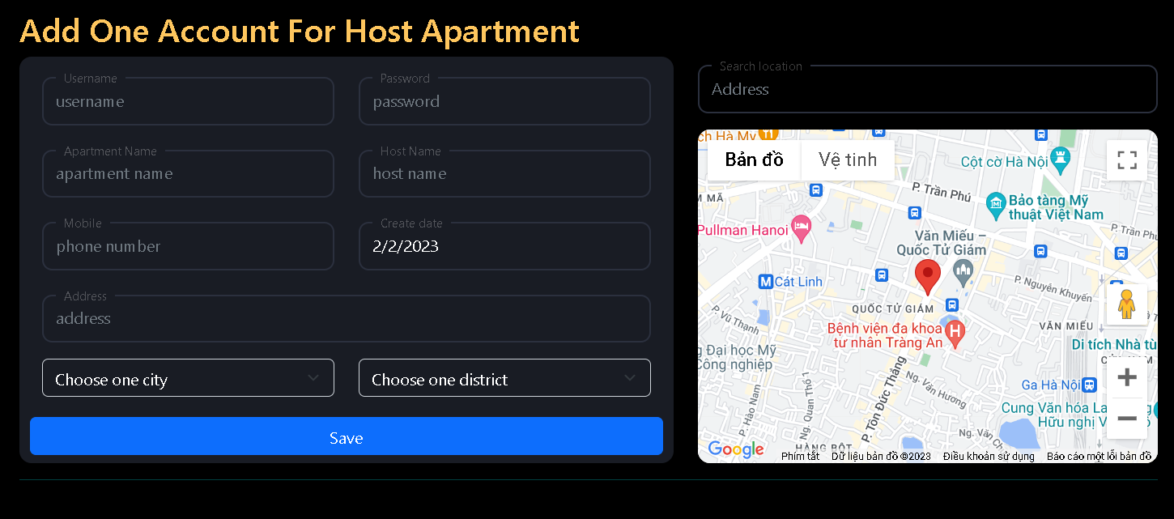

* Function Trigger
  + When admin login into systems
* Function description
  + Actor/Role : Admin
  + Purpose : Created Account Host Apartment for Admin
  + Interface :
    - 6 text fields to fill Username , Password , Phone, Apartment Name , Host Name , Address
    - 2 combobox for City and District

| **UC ID and Name:** | **UC-04. Add Account** | | |
| --- | --- | --- | --- |
| **Created By:** | CongNT | **Date Created:** | 23/01/2023 |
| **Primary Actor:** | Admin | **Secondary Actors:** | N/A |
| **Trigger:** | **TRIG-01.** The Admin Login into Systems | | |
| **Description:** | The function allows the admin created account for host Apartment | | |
| **Preconditions:** | **PRE-01.** Must to login into systems with account Admin | | |
| **Post-conditions:** | **POST-01**. The new account created is updated in the system. | | |
| **Normal Flow:** | **4.0. Add Account Screen**  1. The admin enter information of new account : Username , Password , Phone, Apartment Name , Host Name , Address  2. The user inputs his/her username and presses the “Save” button to continue the process.  3. The system updates a new account and update into database | | |
| **Alternative Flows:** | **4.0.E1. Leave required fields blank**  1. The user is not filling required fields and presses the “Save” button.  2. The system rejects the user’s attempt and displays error messages (MSG01).  **4.0.E2. The user input invalid username**  1. In step 2, The user inputs invalid username.  2. The system rejects the user’s attempt and displays an error message (MSG04).  **4.0.E3. The user inputs wrong password format**  1. The system rejects the user’s attempt, displaying an error message (MSG06).  //Bo sung them bat regex | | |
| **Exceptions:** | N/A | | |
| **Priority:** | High | | |
| **Frequency of Use:** | Low | | |
| **Business Rules:** |  | | |

### 2.2. View List Account Host Apartment

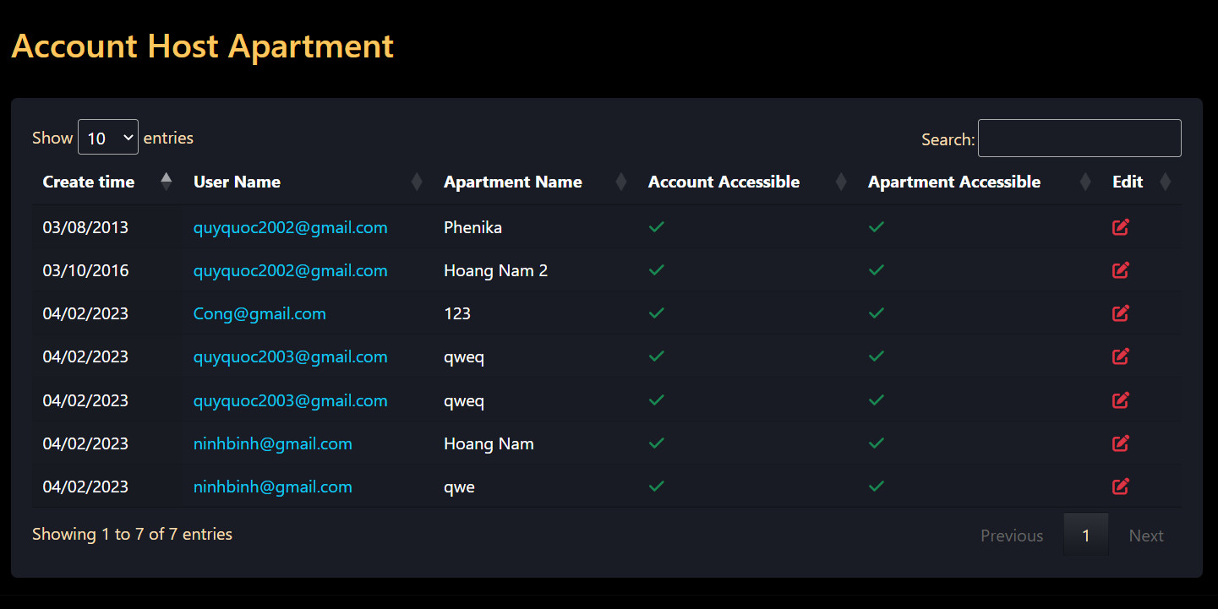

* Function Trigger
  + When admin login into systems
* Function description
  + Actor/Role : Admin
  + Purpose : Show List Account off Host Apartment for Admin
  + Interface :
    - List Account Apartment with Account Accessible and Apartment Accessible active and not active (Account , Apartment)
    - 1 Button to Edit information off account

| **UC ID and Name:** | **UC-05. View List Account** | | |
| --- | --- | --- | --- |
| **Created By:** | CongNT | **Date Created:** | 23/01/2023 |
| **Primary Actor:** | Admin | **Secondary Actors:** | N/A |
| **Trigger:** | **TRIG-01.** The Admin Login into Systems | | |
| **Description:** | The function allows the admin view all list account host Apartment | | |
| **Preconditions:** | **PRE-01.** Must to login into systems with account Admin | | |
| **Post-conditions:** | **POST-01**. Show all list account and status off account | | |
| **Normal Flow:** | **5.0. List Account Screen**  1. The screen displays information of an account including : username , password , Name , Phone , City , District  3 .2 check box to showing the status of account | | |
| **Alternative Flows:** | **5.0.E1.**  1 . Information display box allows admin to edit account information  2. Account status selected by admin (active and inactive)  3. Navigation page number shows current page number and total number of pages to display | | |
| **Exceptions:** | N/A | | |
| **Priority:** | High | | |
| **Frequency of Use:** | Low | | |
| **Business Rules:** |  | | |

### 

### 

### 

### 

### 

### 

### 

### 

### 

### 2.2. Edit Account Host Apartment

* Function Trigger
  + When admin login into systems
* Function description
  + Actor/Role : Admin
  + Purpose : Edit information off Account Host Apartment for Admin
  + Interface :
    - 8 text fields to fill Username , Password , Phone, Apartment Name , Host Name , Address,City,District
    - 2 check box for Active Account And Active Apartment

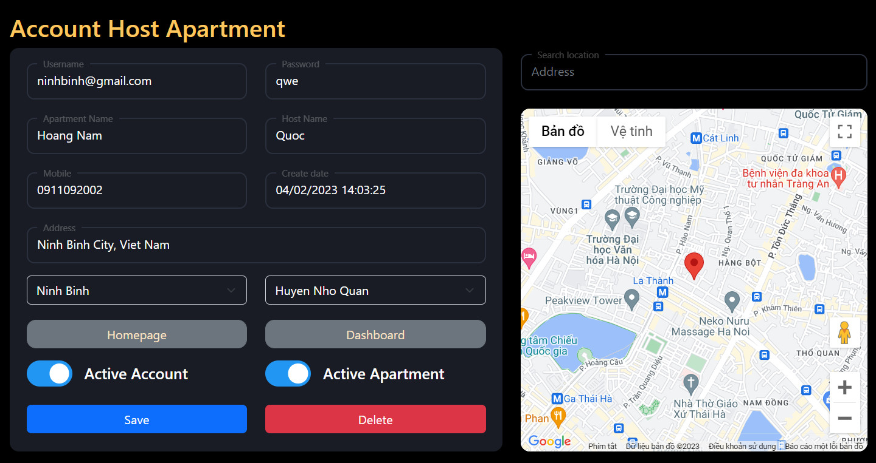

| **UC ID and Name:** | **UC-05. Edit Account Host Apartment** | | |
| --- | --- | --- | --- |
| **Created By:** | CongNT | **Date Created:** | 23/01/2023 |
| **Primary Actor:** | Admin | **Secondary Actors:** | N/A |
| **Trigger:** | **TRIG-01.** The Host Login into Systems | | |
| **Description:** | The function allows the admin edit account host Apartment | | |
| **Preconditions:** | **PRE-01.** Must to login into systems with account Admin | | |
| **Post-conditions:** | **POST-01**. Edit information off Account Host Apartment | | |
| **Normal Flow:** | **8.0. Edit Account Information**  1. The admin enter update information of account : Username , Password , Phone, Apartment Name , Host Name , City , District  2. The user inputs presses the “Save” button to continue the process.  3. The system updates a new account and update into database | | |
| **Alternative Flows:** | **8.0.E1. Leave required fields blank**  1. The user is not filling required fields and presses the “Save” button.  2. The system rejects the user’s attempt and displays error messages (MSG01).  **8.0.E2. The user input invalid username**  1. The user inputs invalid username.  2. The system rejects the user’s attempt and displays an error message (MSG04).  **8.0.E3. The user inputs wrong password format**  1. the user inputs a different password confirmation.  2. The system rejects the user’s attempt, displaying an error message (MSG06).  //bo sung validate | | |
| **Exceptions:** | N/A | | |
| **Priority:** | High | | |
| **Frequency of Use:** | Low | | |

## 3. Feature 3: Manage Staff

### 

### 

### 3.1. View List Staff

* Function Trigger
  + When host login into system and go to Staffs
* Function description
  + Actor/Role : Host
  + Purpose : View List Staff for host apartment
  + Interface :
    - List staff with information : Username , Password , Phone, Apartment Name , Host Name , Address // fix dung truong
    - 2 combobox for Create and Delete Staff

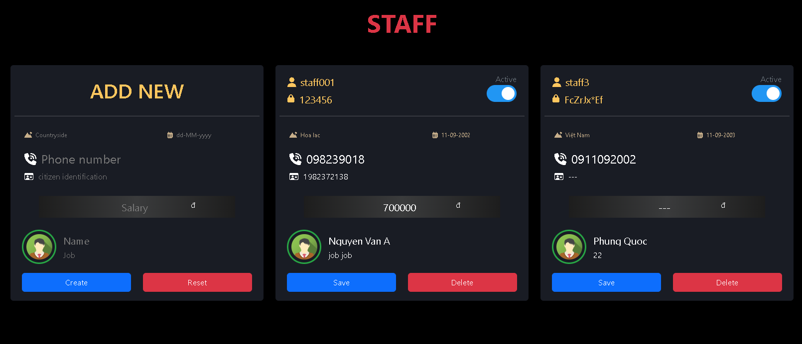

| **UC ID and Name:** | **UC-6. View List Staff** | | |
| --- | --- | --- | --- |
| **Created By:** | TaiNN | **Date Created:** | 24/01/2023 |
| **Primary Actor:** | Host | **Secondary Actors:** | N/A |
| **Trigger:** | **TRIG-01.** The Host Login into Systems | | |
| **Description:** | The function allows the admin view all list staff off one Apartment | | |
| **Preconditions:** | **PRE-01.** Host must to login into systems | | |
| **Post-conditions:** | **POST-01**. Show all list staff and status off account | | |
| **Normal Flow:** | **6.0. List staff Screen**  1. The screen displays information of an account including : Name , Phone , Salary  2. check box to edit and delete staff | | |
| **Alternative Flows:** | **6.0.E1.**  1 . Information display box allows admin to edit account information  2. Account status selected by admin (active and inactive)  3. Navigation page number shows current page number and total number of pages to display | | |
| **Exceptions:** | N/A  //validate name job | | |
| **Priority:** | High | | |
| **Frequency of Use:** | Low | | |
| **Business Rules:** |  | | |

### 

### 3.2. Add Staff

* Function Trigger
  + When host login into system and go to Staffs
* Function description
  + Actor/Role : Host
  + Purpose : Create a Staff for host apartment
  + Interface :
    - 6 textfield to enter: Countryside , date of birth , Phone number , Salary
    - 2 combobox for Create and Reset

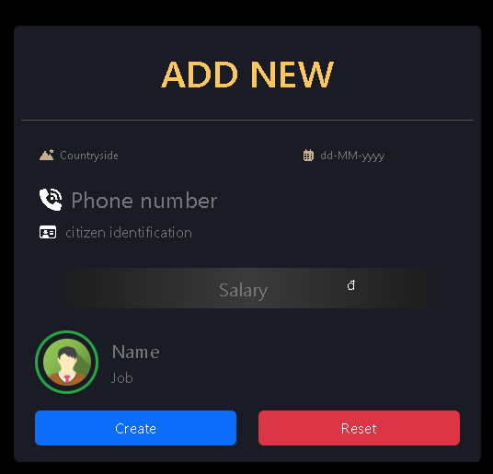

| **UC ID and Name:** | **UC-07. View List Account** | | |
| --- | --- | --- | --- |
| **Created By:** | TaiNN | **Date Created:** | 24/01/2023 |
| **Primary Actor:** | Admin | **Secondary Actors:** | N/A |
| **Trigger:** | **TRIG-01.** The Host Login into Systems | | |
| **Description:** | The function allows the admin view all list account host Apartment | | |
| **Preconditions:** | **PRE-01.** Must to login into systems with account Admin | | |
| **Post-conditions:** | The new Staff created is updated in the system. | | |
| **Normal Flow:** | **7.0. Add staff into Apartment**  1. The admin enter information of account : name , phone , city , salary  2. The user inputs his/her username and presses the “Save” button to continue the process.  3. The system updates a new account and update into database | | |
| **Alternative Flows:** | **7.0.E1. Leave required fields blank**  1. The user is not filling required fields and presses the “Save” button.  2. The system rejects the user’s attempt and displays error messages (MSG01).  **7.0.E2. The user input invalid username**  1. The user inputs invalid username.  2. The system rejects the user’s attempt and displays an error message (MSG04).  **7.0.E3. The user inputs wrong password format**  1. The user inputs a different password confirmation.  2. The system rejects the user’s attempt, displaying an error message (MSG06). | | |
| **Exceptions:** | N/A | | |
| **Priority:** | High | | |
| **Frequency of Use:** | Low | | |
| **Business Rules:** |  | | |

### 

### 

### 

### 3.2. Edit Staff

* Function Trigger
  + When host login into system and go to Staffs
* Function description
  + Actor/Role : Host
  + Purpose : Edit a Staff for host apartment
  + Interface :
    - 6 textfield to enter Countryside , dateofbirth , Phone number , Salary
    - 2 combobox for Save and Reset

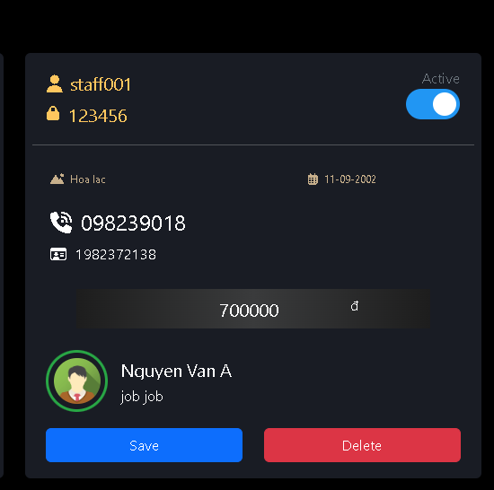

| **UC ID and Name:** | **UC-08. Edit Staff** | | |
| --- | --- | --- | --- |
| **Created By:** | TaiNN | **Date Created:** | 25/01/2023 |
| **Primary Actor:** | Admin | **Secondary Actors:** | N/A |
| **Trigger:** | **TRIG-01.** The Host Login into Systems | | |
| **Description:** | The function allows the admin view all list account host Apartment | | |
| **Preconditions:** | **PRE-01.** Must to login into systems with account Admin | | |
| **Post-conditions:** | **POST-01**. Show all list account and status off account  **POST-02** . Link to HomePage and Dashboard of 1 account | | |
| **Normal Flow:** | **8.0. Edit Account Information**  1. The admin enter update information of account : name , phone , city , Salary  2. The user inputs his/her username and presses the “Save” button to continue the process.  3. The system updates a new account and update into database | | |
| **Alternative Flows:** | **8.0.E1. Leave required fields blank**  1. The user is not filling required fields and presses the “Next” button.  2. The system rejects the user’s attempt and displays error messages (MSG01).  **8.0.E2. The user input invalid username**  1. The user inputs invalid username.  2. The system rejects the user’s attempt and displays an error message (MSG04).  **8.0.E3. The user inputs wrong password format**  1. the user inputs a different password confirmation.  2. The system rejects the user’s attempt, displaying an error message (MSG06). | | |
| **Exceptions:** | N/A | | |
| **Priority:** | High | | |
| **Frequency of Use:** | Low | | |
| **Business Rules:** |  | | |

## 4. Feature 4: ManageHomePage

### 4.1. Edit Introduction

* Function Trigger
  + When Host login into systems and go Apartment Information
* Function description
  + Actor/Role : Host
  + Purpose : Edit introduction For Apartment
  + Interface :
    - 1 toolbar to support for entering information into Text Field
    - 1 textfile to enter Introduction

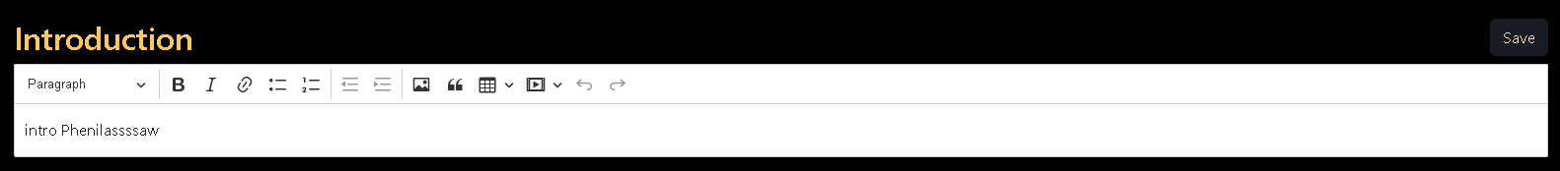

## 

| **UC ID and Name:** | **UC-09. Edit Introduction** | | |
| --- | --- | --- | --- |
| **Created By:** | VietNH | **Date Created:** | 25/01/2023 |
| **Primary Actor:** | Admin | **Secondary Actors:** | N/A |
| **Trigger:** | **TRIG-01.** The Host Login into Systems | | |
| **Description:** | The function allows the host view and edit introduction information | | |
| **Preconditions:** | **PRE-01.** Must to login into systems with account Host | | |
| **Post-conditions:** | **POST-01**. Update new information of Apartment | | |
| **Normal Flow:** | **9.0. Edit Apartment Information**  1. The Host enter new introduction of Apartment  2. The Host presses the “Save” button to continue the process.  3. The system updates a new account and update into database | | |
| **Alternative Flows:** | **9.0.E1. Leave required fields blank**  1. User enters data and does not click save.  2. The systems will not update new information | | |
| **Exceptions:** | N/A | | |
| **Priority:** | High | | |
| **Frequency of Use:** | Low | | |
| **Business Rules:** |  | | |

### 4.2. Add Banner image

* Function Trigger
  + When Host login into systems and go Apartment Information
* Function description
  + Actor/Role : Host
  + Purpose : Add Banner image For Apartment
  + Interface :
    - 1 Button to choose file image and 1 button to Add

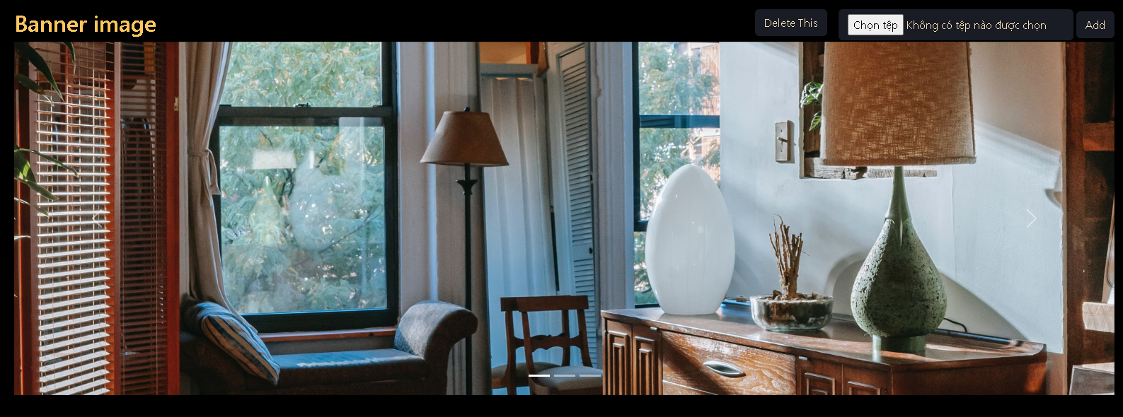

## 

| **UC ID and Name:** | **UC-10. Edit Staff** | | |
| --- | --- | --- | --- |
| **Created By:** | QuocNQ | **Date Created:** | 25/01/2023 |
| **Primary Actor:** | Admin | **Secondary Actors:** | N/A |
| **Trigger:** | **TRIG-01.** The Host Login into Systems | | |
| **Description:** | The function allows the Host Add Banner off Apartment | | |
| **Preconditions:** | **PRE-01.** Must to login into systems with account Host | | |
| **Post-conditions:** | **POST-01**. The new Banner created is updated in the system. | | |
| **Normal Flow:** | **10.0. Add Banner img**   1. The Host enter choose file and select picture   2. The user presses the “Save” button to continue the process.  3. The system updates a new picture and update into database | | |
| **Alternative Flows:** | **10.0.E1. Not Click Save button**  1. The user is not click Save button after choose picture and reload page  2. The system not update new picture and insert into database | | |
| **Exceptions:** | N/A | | |
| **Priority:** | High | | |
| **Frequency of Use:** | Low | | |
| **Business Rules:** |  | | |

### 4.3. Delete Banner image

## 

| **UC ID and Name:** | **UC-11. De** | | |
| --- | --- | --- | --- |
| **Created By:** | QuocNQ | **Date Created:** | 26/01/2023 |
| **Primary Actor:** | Admin | **Secondary Actors:** | N/A |
| **Trigger:** | **TRIG-01.** The Host Login into Systems | | |
| **Description:** | The function allows the Host Delete Banner off Apartment | | |
| **Preconditions:** | **PRE-01.** Must to login into systems with account Host | | |
| **Post-conditions:** | **POST-01**. Remove Banner img | | |
| **Normal Flow:** | **11.0. Delete Banner img**   1. The Host enter Delete 2. The system delete a picture and update into database | | |
| **Alternative Flows:** |  | | |
| **Exceptions:** | N/A | | |
| **Priority:** | High | | |
| **Frequency of Use:** | Low | | |
| **Business Rules:** |  | | |

### 

### 4.4. Edit About us

* Function Trigger
  + When Host login into systems and go Apartment Information
* Function description
  + Actor/Role : Host
  + Purpose : Edit About us For Apartment
  + Interface :
    - 1 toolbar to support for entering information into Text Field
    - 1 textfile to enter Introduction
    - 1 button to save data

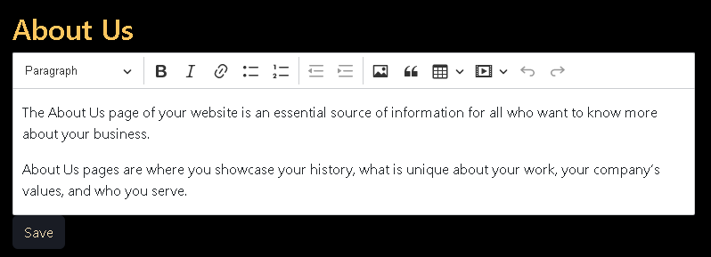

## 

| **UC ID and Name:** | **UC-12. Edit About Us** | | |
| --- | --- | --- | --- |
| **Created By:** | VietNH | **Date Created:** | 26/01/2023 |
| **Primary Actor:** | Admin | **Secondary Actors:** | N/A |
| **Trigger:** | **TRIG-01.** The Host Login into Systems | | |
| **Description:** | The function allows the Host Edit About us off Apartment | | |
| **Preconditions:** | **PRE-01.** Must to login into systems with account Host | | |
| **Post-conditions:** | **POST-01**. Update new information About us of Apartment | | |
| **Normal Flow:** | **12. Edit About us**  1. The Host enter new Abount us of Apartment  2. The Host presses the “Save” button to continue the process.  3. The system updates a new account and update into database | | |
| **Alternative Flows:** | **12.0.E1. Leave required fields blank**  1. User enters data and does not click save.  2. The systems will not update new infomation | | |
| **Exceptions:** | N/A | | |
| **Priority:** | High | | |
| **Frequency of Use:** | Low | | |
| **Business Rules:** |  | | |

### 4.5. Edit Recruitment

## 

| **UC ID and Name:** | **UC-13. Edit Recruitment** | | |
| --- | --- | --- | --- |
| **Created By:** | VietNH | **Date Created:** | 26/01/2023 |
| **Primary Actor:** | Admin | **Secondary Actors:** | N/A |
| **Trigger:** | **TRIG-01.** The Host Login into Systems | | |
| **Description:** | The function allows the Host edit Recruitment | | |
| **Preconditions:** | **PRE-01.** Must to login into systems with account Host | | |
| **Post-conditions:** | **POST-01**. The new Recruitment information is updated in the system. | | |
| **Normal Flow:** | **13.0. Edit Recruitment**  1. The Host enter new information of About us of Apartment  2. The Host presses the “Save” button to continue the process.  3. The system updates a new account and update into database | | |
| **Alternative Flows:** | **13.0.E1. Leave required fields blank**  1. User enters data and does not click save.  2. The systems will not update new information | | |
| **Exceptions:** | N/A | | |
| **Priority:** | High | | |
| **Frequency of Use:** | Low | | |
| **Business Rules:** |  | | |

### 4.6. Edit Service

### 

| **UC ID and Name:** | **UC-13. Edit Service** | | |
| --- | --- | --- | --- |
| **Created By:** | VietNH | **Date Created:** | 26/01/2023 |
| **Primary Actor:** | Admin | **Secondary Actors:** | N/A |
| **Trigger:** | **TRIG-01.** The Host Login into Systems | | |
| **Description:** | The function allows the Host edit Service | | |
| **Preconditions:** | **PRE-01.** Must to login into systems with account Admin | | |
| **Post-conditions:** | **POST-01**. The new Service information is updated in the system. | | |
| **Normal Flow:** | **13.0. Edit Recruitment**  1. The Host enter new information of Service of Apartment  2. The Host presses the “Save” button to continue the process.  3. The system updates a new account and update into database | | |
| **Alternative Flows:** | **13.0.E1. Leave required fields blank**  1. User enters data and does not click save.  2. The systems will not update new infomation | | |
| **Exceptions:** | N/A | | |
| **Priority:** | High | | |
| **Frequency of Use:** | Low | | |
| **Business Rules:** |  | | |

### 4.6. Edit About img

* Function Trigger
  + When Host login into systems and go Apartment Information
* Function description
  + Actor/Role : Host
  + Purpose : Edit About us image For Apartment
  + Interface :
    - 1 Button to choose file image and 1 button to Save

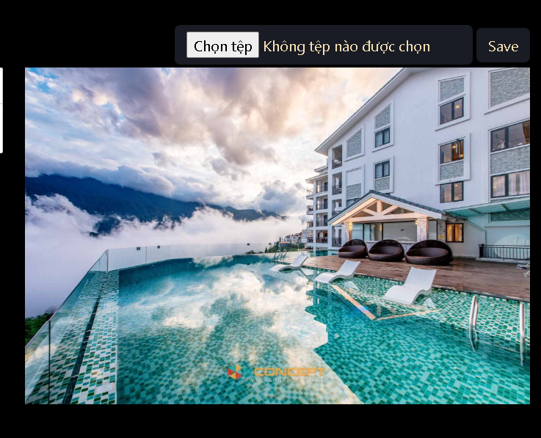

| **UC ID and Name:** | **UC-10. Edit About Us IMG** | | |
| --- | --- | --- | --- |
| **Created By:** | QuocNQ | **Date Created:** | 02/02/2023 |
| **Primary Actor:** | Admin | **Secondary Actors:** | N/A |
| **Trigger:** | **TRIG-01.** The Host Login into Systems | | |
| **Description:** | The function allows the Host Edit Img off About Us | | |
| **Preconditions:** | **PRE-01.** Must to login into systems with account Host | | |
| **Post-conditions:** | **POST-01**. The new Banner created is updated in the system. | | |
| **Normal Flow:** | **10.0. Add Banner img**   1. The Host enter choose file and select picture   2. The user presses the “Save” button to continue the process.  3. The system updates a new picture and update into database | | |
| **Alternative Flows:** | **10.0.E1. Not Click Save button**  1. The user is not click Save button after choose picture and reload page  2. The system not update new picture and insert into database | | |
| **Exceptions:** | N/A | | |
| **Priority:** | High | | |
| **Frequency of Use:** | Low | | |
| **Business Rules:** |  | | |

### 

## 5. Feature 5: RoomManagement

### 5.1. Add Room

* Function Trigger
  + When Host click add in Add room Screen
* Function description
  + Actor/Role : Host
  + Purpose : Create a Room for apartment
  + Interface :
    - 1 textfield to enter: Room Name
    - 2 combobox to select : RoomType and Floor

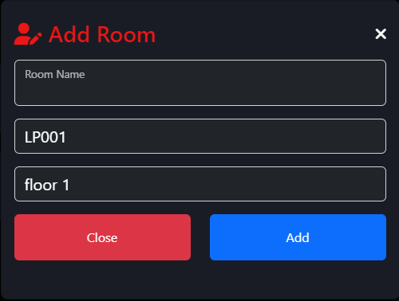

| **UC ID and Name:** | **UC-11. Add Room** | | |
| --- | --- | --- | --- |
| **Created By:** | TaiNN | **Date Created:** | 19/02/2023 |
| **Primary Actor:** | Host | **Secondary Actors:** | N/A |
| **Trigger:** | **TRIG-01.** The Host Add Room for Apartment | | |
| **Description:** | The function allows the host add room for Apartment | | |
| **Preconditions:** | **PRE-01.** Must to login into systems with account Host  **PRE-02.** Room Name does not exist in the systems | | |
| **Post-conditions:** | The new Room created is updated in the system. | | |
| **Normal Flow:** | **11.0. Add Room into Apartment**  1. The admin enter information of account : RoomName  (The user needs to enter the following data: 3 digits at the beginning and 1 in capitals at the end (example : 101A ) )  2. The user select RoomType and Floor off new Room  3. Host click on button “Save”  3. The system updates a new account and update into database | | |
| **Alternative Flows:** |  | | |
| **Exceptions:** | **11.0.E1. Leave required fields blank**  1. The user is not filling required fields and presses the “Save” button.  2. The system rejects the user’s attempt and displays error messages (MSG02).  **11.0.E3. The user input exist RoomName**  1. The user input exist RoomName  2. The system rejects the user’s attempt, displaying an error message (“Room Name Exist, Add Fail”). | | |
| **Priority:** | High | | |
| **Frequency of Use:** | Low | | |
| **Business Rules:** | BR-6 | | |

### 

### 5.2. Show List Room

* Function Trigger
  + When Host click Floor
* Function description
  + Actor/Role : Host
  + Purpose : Show List Rooms for apartment
  + Interface :
    - 4 field to display detail Room: Room Name , RoomType , Status , Thanh Toán
    - 1 link Room Name to Edit information Room

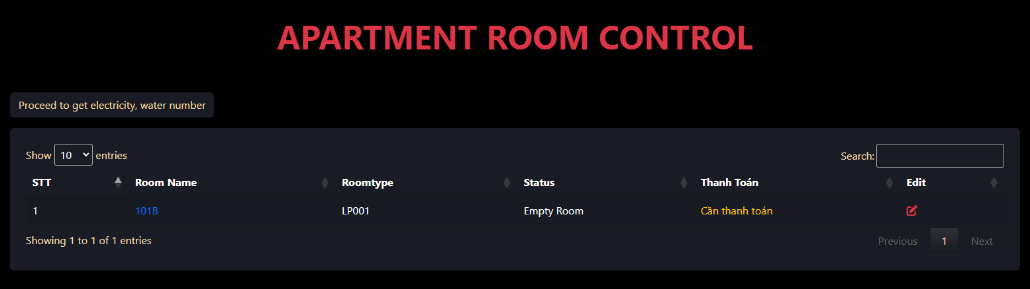

| **UC ID and Name:** | **UC-12. Show List Room** | | |
| --- | --- | --- | --- |
| **Created By:** | TaiNN | **Date Created:** | 19/02/2023 |
| **Primary Actor:** | Host | **Secondary Actors:** | N/A |
| **Trigger:** | **TRIG-01.** The Host click Floor in Room Manage | | |
| **Description:** | The function allows the host view list Room off one Floor | | |
| **Preconditions:** | **PRE-01.** Must to login into systems with account Host  **PRE-02.** Rooms already have created in systems | | |
| **Post-conditions:** | Show list of Rooms | | |
| **Normal Flow:** | 1. Select “Floor” in Room Management  2. The system display all list off Room  3. Select field RoomName of pages to view more information | | |
| **Alternative Flows:** | N/A | | |
| **Exceptions:** | **12.0.E1 User do not select “Floor”** | | |
| **Priority:** | High | | |
| **Frequency of Use:** | Low | | |
| **Business Rules:** | BR-6 | | |

### 

### 5.3. Edit Room

* Function Trigger
  + When Host click RoomName in ListRoom off one Floor
* Function description
  + Actor/Role : Host
  + Purpose : Edit information off Room
  + Interface :
    - 2 field to display detail Room: Room Name , Deposit
    - 2 combobox for “Floor” and “RoomType”

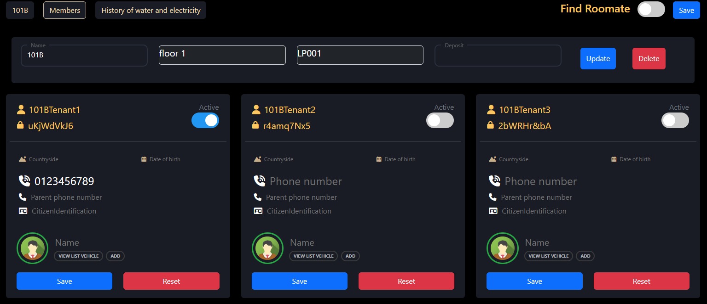

| **UC ID and Name:** | **UC-13. Edit Room** | | |
| --- | --- | --- | --- |
| **Created By:** | TaiNN | **Date Created:** | 19/02/2023 |
| **Primary Actor:** | Host | **Secondary Actors:** | N/A |
| **Trigger:** | **TRIG-01.** The Host click RoomName in list all Room off Floor | | |
| **Description:** | The function allows the host edit Room information off one Floor | | |
| **Preconditions:** | **PRE-01.** Must to login into systems with account Host  **PRE-02.** Rooms already have created in systems | | |
| **Post-conditions:** | Updated new information in the system. | | |
| **Normal Flow:** | 1. Select “RoomName” in list all Rooms off one Floor  2. Display detail off one Room  3. Edit information of Room which need  4. Select button “Update”  5. System validates format and required information successfully  6. Show message “Edit successfully” | | |
| **Alternative Flows:** | N/A | | |
| **Exceptions:** | **13.1 Information RoomName is not invalid** | | |
| **Priority:** | High | | |
| **Frequency of Use:** | Low | | |
| **Business Rules:** | BR-6 | | |

### 

### 5.4. Delete Room

* Function Trigger
  + When Host click Delete in RoomDetail
* Function description
  + Actor/Role : Host
  + Purpose : Delete Room
  + Interface :
    - 1 button to Delete Room
    - 1 Message box to confirm

| **UC ID and Name:** | **UC-14. Edit Room** | | |
| --- | --- | --- | --- |
| **Created By:** | TaiNN | **Date Created:** | 19/02/2023 |
| **Primary Actor:** | Host | **Secondary Actors:** | N/A |
| **Trigger:** | **TRIG-01.** The Host click Delete in RoomDetail | | |
| **Description:** | The function allows the host Delete Room | | |
| **Preconditions:** | **PRE-01.** Must to login into systems with account Host  **PRE-02.** Rooms already have created in systems | | |
| **Post-conditions:** | Delete Room | | |
| **Normal Flow:** | 1. Select “Delete” in Room Detail  2. Display message box to confirm Delete  3. Select button “Delete” in message box  5. System validates format and required information successfully  6. Show message “Edit course successfully” | | |
| **Alternative Flows:** | N/A | | |
| **Exceptions:** | **13.1 Tenant Still Actived in Room want to Delete** | | |
| **Priority:** | High | | |
| **Frequency of Use:** | Low | | |
| **Business Rules:** | BR-6 | | |

## 6. Feature 6: RoomTypeManagement

### 6.1. Add RoomType

* Function Trigger
  + When Host click add in RoomType Screen
* Function description
  + Actor/Role : Host
  + Purpose : Create a RoomType for apartment
  + Interface :
    - 4 textfield to enter: Name , Max Member , Cost , Area
    - 1 button to add RoomType

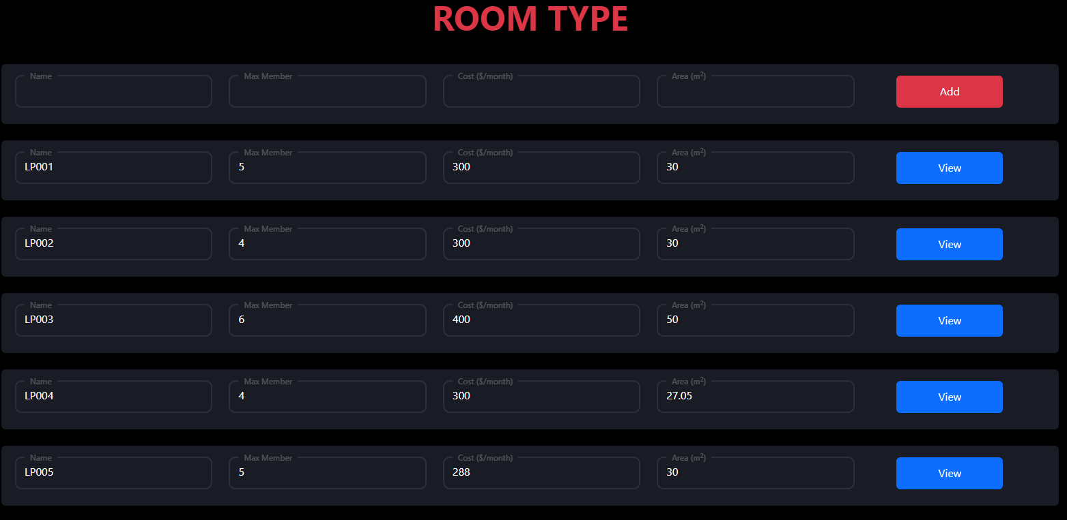

| **UC ID and Name:** | **UC-15. Add RoomType** | | |
| --- | --- | --- | --- |
| **Created By:** | TaiNN | **Date Created:** | 19/02/2023 |
| **Primary Actor:** | Host | **Secondary Actors:** | N/A |
| **Trigger:** | **TRIG-01.** The Host Add RoomType | | |
| **Description:** | The function allows the host add new Room Type for Apartment | | |
| **Preconditions:** | **PRE-01.** Must to login into systems with account Host | | |
| **Post-conditions:** | The new RoomType created is updated in the system. | | |
| **Normal Flow:** | **15.0. Add room type into Apartment**  1. The admin enter information of account : Name , Max Member , Cost , Area  3. Host click on button “Save”  3. The system updates a new account and update into database | | |
| **Alternative Flows:** |  | | |
| **Exceptions:** | **15.1.E1. Leave required fields blank**  1. The user is not filling required fields and presses the “Save” button.  2. The system rejects the user’s attempt and displays error messages (MSG01).  **15.2.E1. Name off Room Type is wrong format**   1. Room Types name is malformed (LP000)   **15.3.E1. Name off Room Type is exist in systems** | | |
| **Priority:** | High | | |
| **Frequency of Use:** | Low | | |
| **Business Rules:** | BR-6 | | |

### 

### 

### 

### 

### 

### 

### 

### 

### 6.2. Show RoomType List

* Function Trigger
  + When Host click to RoomType
* Function description
  + Actor/Role : Host
  + Purpose : View list RoomType for apartment
  + Interface :
    - 4 textfield to enter: Name , Max Member , Cost , Area
    - 1 button to view detail RoomType

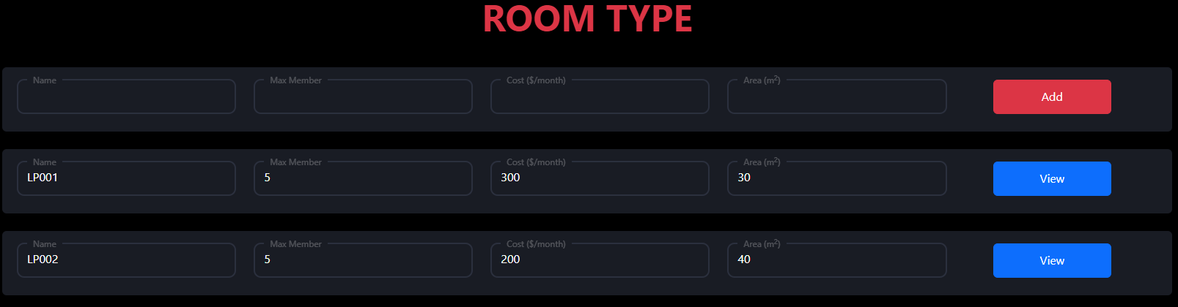

| **UC ID and Name:** | **UC-16. View RoomType List** | | |
| --- | --- | --- | --- |
| **Created By:** | TaiNN | **Date Created:** | 19/02/2023 |
| **Primary Actor:** | Host | **Secondary Actors:** | N/A |
| **Trigger:** | **TRIG-01.** The Host click RoomType | | |
| **Description:** | The function allows the host view all list Room Type | | |
| **Preconditions:** | **PRE-01.** Must to login into systems with account Host | | |
| **Post-conditions:** | Show list of all Rooms Type | | |
| **Normal Flow:** | 1. Select “RoomType” in menu bar Room Management  2. The system display grid of Rooms type | | |
| **Alternative Flows:** | N/A | | |
| **Exceptions:** |  | | |
| **Priority:** | High | | |
| **Frequency of Use:** | Low | | |
| **Business Rules:** | BR-6 | | |

### 6.3. Show RoomType Detail

* Function Trigger
  + When Host click to RoomType
* Function description
  + Actor/Role : Host
  + Purpose : Create a RoomType for apartment
  + Interface :
    - 4 textfield to enter: Name , Max Member , Cost , Area
    - 1 button to view detail RoomType

| **UC ID and Name:** | **UC-16. View RoomType List** | | |
| --- | --- | --- | --- |
| **Created By:** | TaiNN | **Date Created:** | 19/02/2023 |
| **Primary Actor:** | Host | **Secondary Actors:** | N/A |
| **Trigger:** | **TRIG-01.** The Host click view in one RoomType | | |
| **Description:** | The function allows the host view Room Type detail | | |
| **Preconditions:** | **PRE-01.** Must to login into systems with account Host | | |
| **Post-conditions:** | Show detail RoomType | | |
| **Normal Flow:** | 1. Select “View” in one off Room Type  2. The system display information off Room Type : Name , Maxmember , Cost , Area | | |
| **Alternative Flows:** | N/A | | |
| **Exceptions:** | User not select in View button | | |
| **Priority:** | High | | |
| **Frequency of Use:** | Low | | |
| **Business Rules:** | BR-6 | | |

### 

### 

### 6.4. Edit RoomType

* Function Trigger
  + When Host click button “Save” in Room Type detail
* Function description
  + Actor/Role : Host
  + Purpose : Edit information off Room Type
  + Interface :
    - 5 field to edit detail Room: RoomTypeName , MaxMember , Cost , Area
    - 1 combobox for “Save”

| **UC ID and Name:** | **UC-17. Edit RoomType** | | |
| --- | --- | --- | --- |
| **Created By:** | TaiNN | **Date Created:** | 19/02/2023 |
| **Primary Actor:** | Host | **Secondary Actors:** | N/A |
| **Trigger:** | **TRIG-01.** The Host click Save in Room type detail | | |
| **Description:** | The function allows the host edit RoomType | | |
| **Preconditions:** | **PRE-01.** Must to login into systems with account Host  **PRE-02.** There are no rooms currently using the room type you want to fix | | |
| **Post-conditions:** | Updated new information in the system. | | |
| **Normal Flow:** | 1. Select “RoomName” in list all Rooms off one Floor  2. Display detail off one Room  3. Edit information of Room which need  4. Select button “Update”  5. System validates format and required information successfully  6. Show message “Edit course successfully” | | |
| **Alternative Flows:** | N/A | | |
| **Exceptions:** | **17.1 Information RoomName is not invalid** | | |
| **Priority:** | High | | |
| **Frequency of Use:** | Low | | |
| **Business Rules:** | BR-6 | | |

### 6.5. Edit RoomType Img

* Function Trigger
  + Click Edit img button
* Function description
  + Actor/Role : Host
  + Purpose : Edit Room Type image Interface :
    - 1 Button to choose file image and 1 button to Save

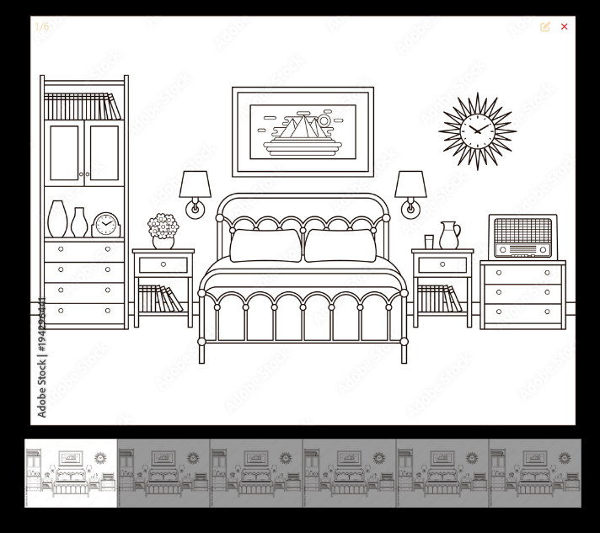

| **UC ID and Name:** | **UC-18. Edit About Us IMG** | | |
| --- | --- | --- | --- |
| **Created By:** | QuocNQ | **Date Created:** | 02/02/2023 |
| **Primary Actor:** | Admin | **Secondary Actors:** | N/A |
| **Trigger:** | **TRIG-01.** The Host Login into Systems | | |
| **Description:** | The function allows the Host Edit Img off About Us | | |
| **Preconditions:** | **PRE-01.** Must to login into systems with account Host | | |
| **Post-conditions:** | **POST-01**. The new Banner created is updated in the system. | | |
| **Normal Flow:** | **18.0. Add Banner img**   1. The Host enter choose file and select picture   2. The user presses the “Save” button to continue the process.  3. The system updates a new picture and update into database | | |
| **Alternative Flows:** | **18.0.E1. Not Click Save button**  1. The user is not click Save button after choose picture and reload page  2. The system not update new picture and insert into database | | |
| **Exceptions:** | N/A | | |
| **Priority:** | High | | |
| **Frequency of Use:** | Low | | |
| **Business Rules:** | BR-6 | | |

### 

### 6.6. Delete RoomType Img

## 

| **UC ID and Name:** | **UC-19. De** | | |
| --- | --- | --- | --- |
| **Created By:** | QuocNQ | **Date Created:** | 26/01/2023 |
| **Primary Actor:** | Admin | **Secondary Actors:** | N/A |
| **Trigger:** | **TRIG-01.** The Host Login into Systems | | |
| **Description:** | The function allows the Host Delete Banner off Apartment | | |
| **Preconditions:** | **PRE-01.** Must to login into systems with account Host  **PRE-02 .**The deleted image is not the default image | | |
| **Post-conditions:** | **POST-01**. Remove RoomType img | | |
| **Normal Flow:** | 1. The Host enter Delete  2. The system delete a picture and update into database | | |
| **Alternative Flows:** | N/A | | |
| **Exceptions:** | N/A | | |
| **Priority:** | High | | |
| **Frequency of Use:** | Low | | |
| **Business Rules:** | BR-6 | | |

## 7. Feature 7: Floor Management

### 7.1. Add Floor

* Function Trigger
  + The Host Click Add Floor in Add Floor Screen
* Function description
  + Actor/Role : Host
  + Purpose : Create a Floor for apartment
  + Interface :
    - 1 textfield to enter: Room Name
    - 2 combobox to select : RoomType and Floor

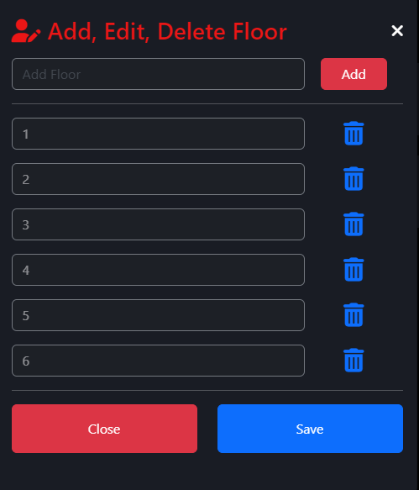

| **UC ID and Name:** | **UC-20. Add Floor** | | |
| --- | --- | --- | --- |
| **Created By:** | TaiNN | **Date Created:** | 19/02/2023 |
| **Primary Actor:** | Host | **Secondary Actors:** | N/A |
| **Trigger:** | **TRIG-01.** The Host Click Add Floor in Add Floor Screen | | |
| **Description:** | The function allows the host add floor for Apartment | | |
| **Preconditions:** | **PRE-01.** Must to login into systems with account Host  **PRE-02 .** Floor must be a number  **PRE-03 .** Floor name cannot be duplicated  **PRE-04 .** Floor name must be unique | | |
| **Post-conditions:** | The new Floor created is updated in the system. | | |
| **Normal Flow:** | **20.0. Add Floor into Apartment**  1. The Host enter information of Floor : Number Floor  2. Host click on button “Add”  3. The system updates a new account and update into database | | |
| **Alternative Flows:** |  | | |
| **Exceptions:** | **20.0.E1. Leave required fields blank**  1. The user is not filling required fields and presses the “Save” button.  2. The system rejects the user’s attempt and displays error messages (MSG01). | | |
| **Priority:** | High | | |
| **Frequency of Use:** | Low | | |
| **Business Rules:** | BR-6 , BR-09, BR-11 | | |

### 

### 

### 

### 7.2. Show List Floors

* Function Trigger
  + When Host click Room Management in menu bar
* Function description
  + Actor/Role : Host
  + Purpose : Show List Floors

| **UC ID and Name:** | **UC-21. Show List Floors** | | |
| --- | --- | --- | --- |
| **Created By:** | TaiNN | **Date Created:** | 19/02/2023 |
| **Primary Actor:** | Host | **Secondary Actors:** | N/A |
| **Trigger:** | **TRIG-01.** The Host click Room Management in menu bar | | |
| **Description:** | The function allows the host view list Floors | | |
| **Preconditions:** | **PRE-01.** Must to login into systems with account Host  **PRE-02.** Floor already have created at least one in systems | | |
| **Post-conditions:** | Show list of Floors | | |
| **Normal Flow:** | 1. Select “Room Management” in menu bar  2. The system display all list off Floor | | |
| **Alternative Flows:** | N/A | | |
| **Exceptions:** | **21.0.E1 User do not select “Floor”** | | |
| **Priority:** | High | | |
| **Frequency of Use:** | Low | | |
| **Business Rules:** | BR-6 | | |

### 7.3. Edit Floor

* Function Trigger
  + When Host click Save in Floor Control
* Function description
  + Actor/Role : Host
  + Purpose : Edit information off Floor
  + Interface :
    - 1 field to edit floor Name

| **UC ID and Name:** | **UC-13. Edit Room** | | |
| --- | --- | --- | --- |
| **Created By:** | TaiNN | **Date Created:** | 19/02/2023 |
| **Primary Actor:** | Host | **Secondary Actors:** | N/A |
| **Trigger:** | **TRIG-01.** When Host click Save in Floor Control | | |
| **Description:** | The function allows the host edit Floor information | | |
| **Preconditions:** | **PRE-01.** Must to login into systems with account Host  **PRE-02.** Floor name must be a number | | |
| **Post-conditions:** | Updated new information in the system. | | |
| **Normal Flow:** | 1. Select “Floor” in Apartment Room Control  2. Display detail Floor  3. Edit information of Floor which need  4. Select button “Save”  5. System validates format and required information successfully  6. Show message “Edit Floor successfully” | | |
| **Alternative Flows:** | N/A | | |
| **Exceptions:** | **13.1 Information RoomName is not invalid** | | |
| **Priority:** | High | | |
| **Frequency of Use:** | Low | | |
| **Business Rules:** | BR-6 | | |

### 7.4. Delete Floor

| **UC ID and Name:** | **UC-15. Delete Floor** | | |
| --- | --- | --- | --- |
| **Created By:** | TaiNN | **Date Created:** | 19/02/2023 |
| **Primary Actor:** | Host | **Secondary Actors:** | N/A |
| **Trigger:** | **TRIG-01.** Click to “Delete Button ” in Floor Screen | | |
| **Description:** | The function allows the Host Delete Floor Apartment | | |
| **Preconditions:** | **PRE-01.** Must to login into systems with account Host  **PRE-02.** No active rooms in the floor will be deleted | | |
| **Post-conditions:** | **POST-01**. Remove Floor | | |
| **Normal Flow:** | **15.0. Delete Floor**   1. The Host click “Garbage Button” 2. Show the message Are you sure delete “Floor number” 3. Host click to Delete Button to confirm 4. The system delete Floor and update into database | | |
| **Alternative Flows:** |  | | |
| **Exceptions:** | N/A | | |
| **Priority:** | High | | |
| **Frequency of Use:** | Low | | |
| **Business Rules:** | BR-6 | | |

## 

## 8. Feature 8: Tenent Management

### 8.1. Show Tenant

* Function Trigger
  + When Host click RoomName in ListRoom
* Function description
  + Actor/Role : Host
  + Purpose : View list tenant off one Room
  + Interface :
    - Display detail Room: Tenant Name Account , Password , Phone Number , Phone Parent Phone Number , Name Tenant
    - 2 combobox for “Edit” and “Delete” Tenant

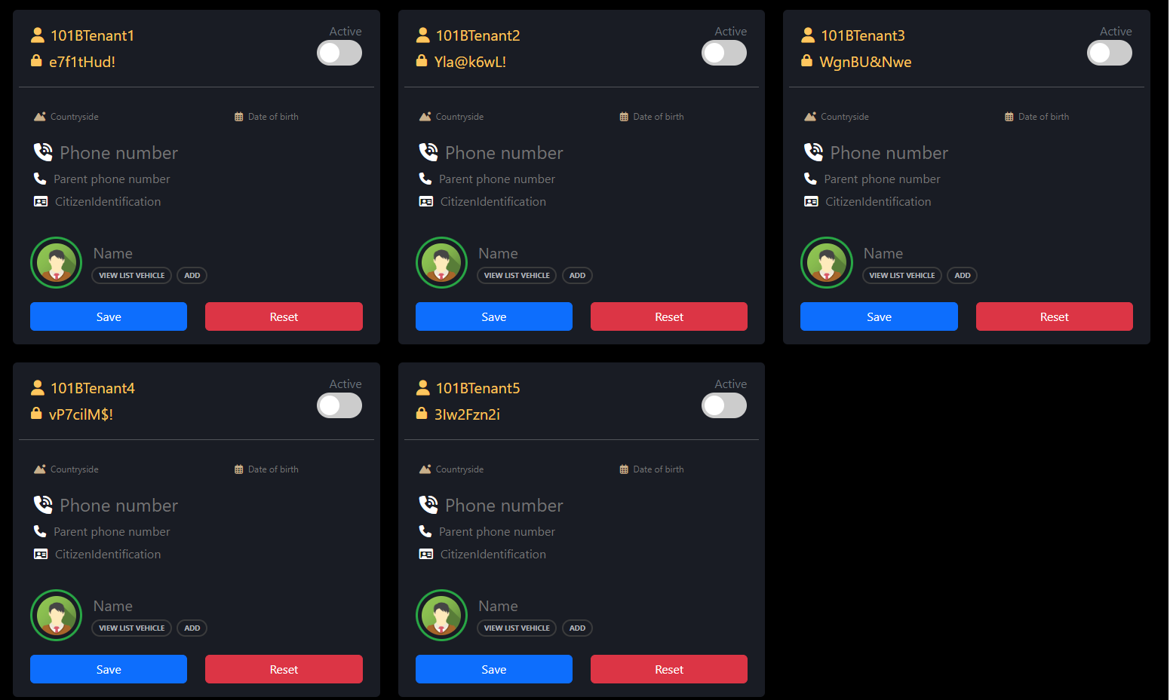

| **UC ID and Name:** | **UC-16. Show Tenant** | | |
| --- | --- | --- | --- |
| **Created By:** | TaiNN | **Date Created:** | 19/02/2023 |
| **Primary Actor:** | Host | **Secondary Actors:** | N/A |
| **Trigger:** | **TRIG-01.** The Host click RoomName in list all Room off Floor | | |
| **Description:** | Show list tenant off one Room | | |
| **Preconditions:** | **PRE-01.** Must to login into systems with account Host  **PRE-02.** Rooms already have created in systems | | |
| **Post-conditions:** | View All Tenant off one room | | |
| **Normal Flow:** | 1. Select “RoomName” in list all Rooms off one Floor  2. Display detail off one Room | | |
| **Alternative Flows:** | N/A | | |
| **Exceptions:** | **16.1 Host not click to RoomName in list all Room off Floor** | | |
| **Priority:** | High | | |
| **Frequency of Use:** | Low | | |
| **Business Rules:** | BR-6 | | |

### 8.2. Edit Tenant

* Function Trigger
  + When host click to button “Save” in an information storage cell off tenant
* Function description
  + Actor/Role : Host
  + Purpose : Edit Tenant
  + Interface :
    - 6 textfield to enter Countryside , date of birth , Phone number , Parent phone number , Citizenldentification , Name
    - 1 button “Active”

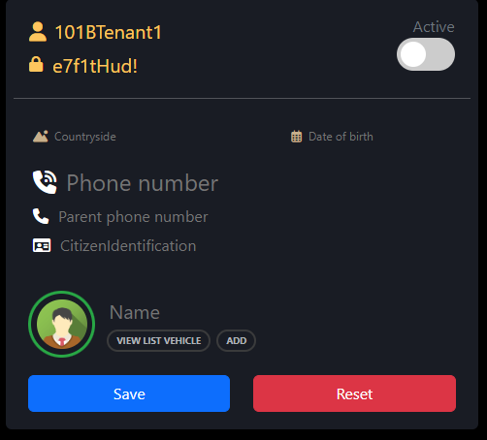

| **UC ID and Name:** | **UC-17. Edit Tenant** | | |
| --- | --- | --- | --- |
| **Created By:** | TaiNN | **Date Created:** | 25/01/2023 |
| **Primary Actor:** | Admin | **Secondary Actors:** | N/A |
| **Trigger:** | **TRIG-01.** When host click to button “Save” in an information storage cell off tenant | | |
| **Description:** | The function allows the host edit tenant | | |
| **Preconditions:** | **PRE-01.** Must to login into systems with account Admin  **PRE-02 .** Phone number must be digit  **PRE-03 .** Citizen Identification must be valid | | |
| **Post-conditions:** | **POST-01**. Save the latest information of Tenant | | |
| **Normal Flow:** | **17.0. Edit Tenant Information**  1. The admin enter update information of account : Countryside , date of birth , Phone number , Parent phone number , Citizenldentification , Name  (The fields will be checked to see if the received data matches)  2. The user inputs his/her username and presses the “Save” button to continue the process.  3. The system updates a new account and update into database | | |
| **Alternative Flows:** | **17.0.E1. Leave required fields blank**  1. The user is not filling required fields and presses the “Next” button.  2. The system rejects the user’s attempt and displays error messages (MSG01).  **17.0.E2. The user input invalid phone number**  1. The user inputs invalid phone number.  2. The system rejects the user’s attempt and displays an error message (MSG04).  **17.0.E3. The user inputs wrong** Citizen Identification  1. The user inputs invalid Citizen Identification  2. The system rejects the user’s attempt, displaying an error message (MSG06). | | |
| **Exceptions:** | N/A | | |
| **Priority:** | High | | |
| **Frequency of Use:** | Low | | |
| **Business Rules:** | BR-6 , BR-02 , BR-07 | | |

### 8.3. Delete Tenant

* Function Trigger
  + When Host click Delete in RoomDetail
* Function description
  + Actor/Role : Host
  + Purpose : Delete Room
  + Interface :
    - 2 button for “Reset” and “Active” to remove

### 

| **UC ID and Name:** | **UC-18. Delete Tenant** | | |
| --- | --- | --- | --- |
| **Created By:** | TaiNN | **Date Created:** | 19/02/2023 |
| **Primary Actor:** | Host | **Secondary Actors:** | N/A |
| **Trigger:** | **TRIG-01.** Click to “Delete Button ” in Staff want to delete | | |
| **Description:** | The function allows the Host Delete Tenant | | |
| **Preconditions:** | **PRE-01.** Must to login into systems with account Host | | |
| **Post-conditions:** | **POST-01**. Remove Tenant | | |
| **Normal Flow:** | **18.0. Delete Floor**   1. The Host click “Reset button” 2. Information off tenant will be reset 3. Click to “Active” to inactive tenant | | |
| **Alternative Flows:** | N/A | | |
| **Exceptions:** | N/A | | |
| **Priority:** | High | | |
| **Frequency of Use:** | Low | | |
| **Business Rules:** | BR-6 | | |

## 9. Feature 9: Vehicle Management

### 9.1. Add Vehicle

* Function Trigger
  + Click button Save in Add Vehicle form
* Function description
  + Actor/Role : Host
  + Purpose : Create a vehicle for tenant apartment
  + Interface :
    - 1 combobox to select type vehicle
    - 2 text field for Description and License Plate

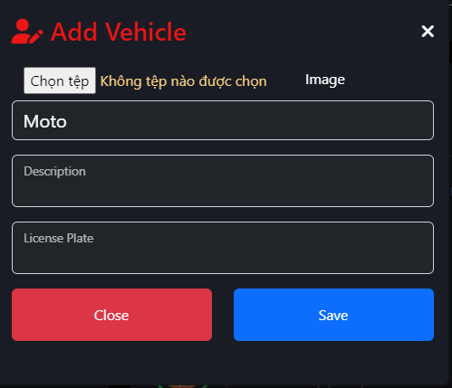

| **UC ID and Name:** | **UC-19. Add Vehicle** | | |
| --- | --- | --- | --- |
| **Created By:** | TaiNN | **Date Created:** | 19/02/2023 |
| **Primary Actor:** | Host | **Secondary Actors:** | N/A |
| **Trigger:** | **TRIG-01.** Click button Save in Add Vehicle form | | |
| **Description:** | The function allows the host add vehicle for tenant | | |
| **Preconditions:** | **PRE-01.** Must to login into systems with account Host  **PRE-02.** Picture off vehicle must be select | | |
| **Post-conditions:** | The new vehicle created is updated in the system. | | |
| **Normal Flow:** | **19.0. Add vehicle into Apartment**  1. The admin enter information of vehicle : Description and License Plate  2. The user select Vehicle Type and picture off vehicle  4. Host click on button “Save”  3. The system updates a new account and update into database | | |
| **Alternative Flows:** |  | | |
| **Exceptions:** | **19.0.E1. Leave required fields blank**  1. The user is not filling required fields and presses the “Save” button.  2. The system rejects the user’s attempt and displays error messages (MSG01). | | |
| **Priority:** | High | | |
| **Frequency of Use:** | Low | | |
| **Business Rules:** | BR-6 , BR-8 | | |

### 9.3. Show Vehicle

* Function Trigger
  + When Host click to View List Vehicle
* Function description
  + Actor/Role : Host
  + Purpose : View all list Vehicle
  + Interface :
    - Display detail vehicle: Type , License Plate, Tenant Name , Room Name , Description , Image

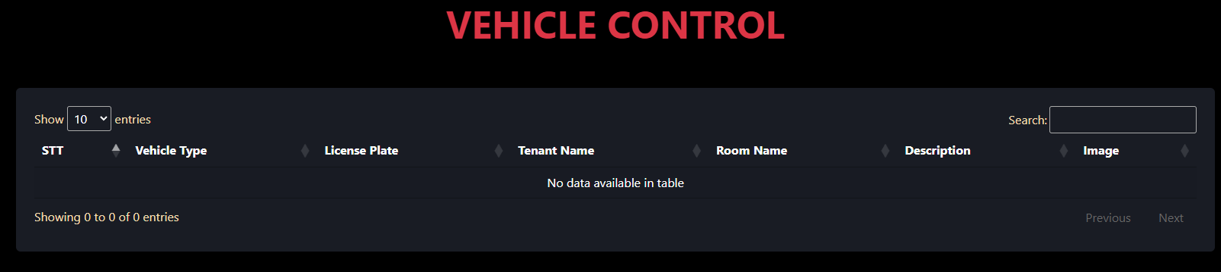

| **UC ID and Name:** | **UC-20. Show Vehicle** | | |
| --- | --- | --- | --- |
| **Created By:** | TaiNN | **Date Created:** | 19/02/2023 |
| **Primary Actor:** | Host | **Secondary Actors:** | N/A |
| **Trigger:** | **TRIG-01.** When Host click to Vehicle in menu bar | | |
| **Description:** | Show list vehicle | | |
| **Preconditions:** | **PRE-01.** Must to login into systems with account Host  **PRE-02.** Vehicle already have created in systems | | |
| **Post-conditions:** | View all vehicle off one Tenant | | |
| **Normal Flow:** | 1. Select “Vehicle”  2. Display list off vehicle | | |
| **Alternative Flows:** | N/A | | |
| **Exceptions:** | **20.1 Host not click to Vehicle** | | |
| **Priority:** | High | | |
| **Frequency of Use:** | Low | | |
| **Business Rules:** | BR-6 | | |

### 9.5. Delete Vehicle

* Function Trigger
  + When Host click button “Delete” in View List Vehicles form
* Function description
  + Actor/Role : Host
  + Purpose : Delete Vehicle
  + Interface :
    - Display detail vehicle: Type , Description , License Plate , View
    - 1 combobox for “Delete” Vehicle

### 

| **UC ID and Name:** | **UC-21. Delete Vehicle** | | |
| --- | --- | --- | --- |
| **Created By:** | TaiNN | **Date Created:** | 19/02/2023 |
| **Primary Actor:** | Host | **Secondary Actors:** | N/A |
| **Trigger:** | **TRIG-01.** When Host click button “Delete” in View List Vehicles form | | |
| **Description:** | The function allows the Host Delete Vehicle | | |
| **Preconditions:** | **PRE-01.** Must to login into systems with account Host  **PRE-02.** Vehicle already have created in systems | | |
| **Post-conditions:** | **POST-01**. Delete Vehicle | | |
| **Normal Flow:** | **21.0. Delete Floor**   1. The Host click “Delete button” 2. Click “Garbage” icon to confirm 3. Systems delete Vehicle and update database | | |
| **Alternative Flows:** | N/A | | |
| **Exceptions:** | N/A | | |
| **Priority:** | High | | |
| **Frequency of Use:** | Low | | |
| **Business Rules:** | BR-6 | | |

## 10. Feature 10: HomePage Customer

### 10.1. Search apartment (index)

* Function Trigger
  + Click “Search Button” in HomePage
* Function description
  + Actor/Role : Host
  + Purpose : Edit Room Type image Interface :
    - 2 combobox to select City and District for first type search
    - 1 button to change type search
    - 1 text file to search for name Apartment

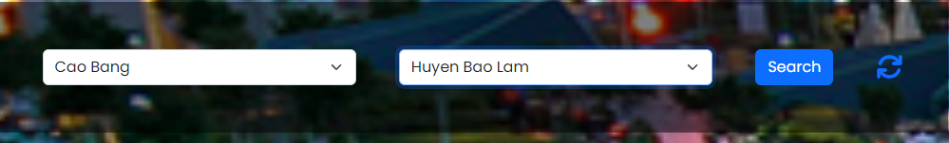

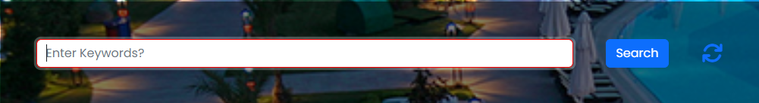

### 

| **UC ID and Name:** | **UC-22. Search Apartment** | | |
| --- | --- | --- | --- |
| **Created By:** | TaiNN | **Date Created:** | 19/02/2023 |
| **Primary Actor:** | Host | **Secondary Actors:** | N/A |
| **Trigger:** | **TRIG-01.** When Host click button “Search” in HomePage | | |
| **Description:** | The function allows the user view all Apartment by search method | | |
| **Preconditions:** | **PRE-01.** Apartment must be exist in systems | | |
| **Post-conditions:** | **POST-01**. View list Apartment | | |
| **Normal Flow:** | **22.0. Search with City and District**   1. The user select “City” and “District” 2. Click “Search” to find Apartment 3. List Apartment show   **22.1. Search with Keywords**   1. The user enter keywords 2. Click “Search” to find Apartment 3. List Apartment show | | |
| **Alternative Flows:** | N/A | | |
| **Exceptions:** | **22.1 Host not click to “Search” button**  **22.2 Keywords not invalid**  **22.3 Apartment not exist in systems** | | |
| **Priority:** | High | | |
| **Frequency of Use:** | Low | | |
| **Business Rules:** | BR-6 | | |

### 10.2. Contact

* Function Trigger
  + Click “Search Button” in HomePage
* Function description
  + Actor/Role : Host
  + Purpose : Send contact to Host :
    - 4 text field to enter : Name , Email , Phone Number

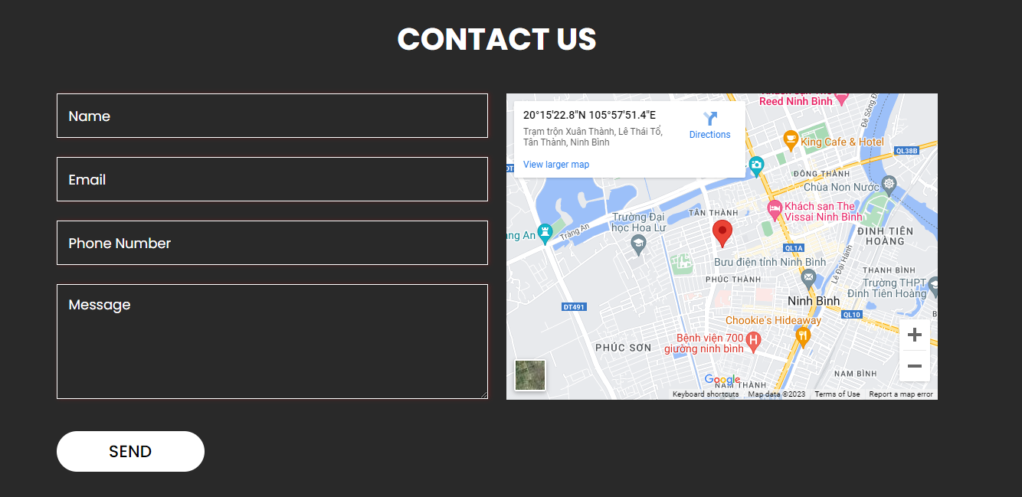

### 10.3. View Contact for Host

* Function Trigger
  + Go Contact in HomePage of Apartment
* Function description
  + Actor/Role : Host
  + Purpose : ViewList Contact :
    - 4 text field to Show information : Name , Email , Phone Number

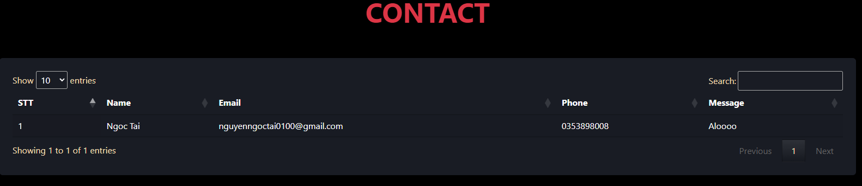

| **UC ID and Name:** | **UC-22. Show Contact** | | |
| --- | --- | --- | --- |
| **Created By:** | TaiNN | **Date Created:** | 19/02/2023 |
| **Primary Actor:** | Host | **Secondary Actors:** | N/A |
| **Trigger:** | **TRIG-01.** Go Contact in HomePage of Apartment | | |
| **Description:** | Show contact detail | | |
| **Preconditions:** | **PRE-01.** Must to login into systems with account Host | | |
| **Post-conditions:** | View all contact off Apartment | | |
| **Normal Flow:** | 1. Select “Contact” in menu bar  2. Display list off Contact | | |
| **Alternative Flows:** | N/A | | |
| **Exceptions:** | **20.1 Host not click to Contact** | | |
| **Priority:** | High | | |
| **Frequency of Use:** | Low | | |
| **Business Rules:** | BR-6 | | |

### 10.4. Search apartment by Distance

| **UC ID and Name:** | **UC-23. Search apartment by Distance** | | |
| --- | --- | --- | --- |
| **Created By:** | TaiNN | **Date Created:** | 10/03/2023 |
| **Primary Actor:** | Host | **Secondary Actors:** | N/A |
| **Trigger:** | **TRIG-01.** Click to “Map Icon ”in HomePage | | |
| **Description:** | Show all Apartment within 10km | | |
| **Preconditions:** | **PRE-01.** Need to specify the location to search | | |
| **Post-conditions:** | Search all hostels within a 10km radius of the desired location | | |
| **Normal Flow:** | 1. Select “Map icon ” in menu bar  2. Display all apartment within by distance  3. Select number off page to view more Apartment | | |
| **Alternative Flows:** | N/A | | |
| **Exceptions:** | **20.1. When user blocks the current location** | | |
| **Priority:** | Low | | |
| **Frequency of Use:** | Low | | |
| **Business Rules:** | BR-12 | | |

### 

## 11. Feature 11: Payment Management

### 

### 11.1. Payment

* Function Trigger
  + When Host click to Electric/Water icon
* Function description
  + Actor/Role : Host
  + Purpose :  **Get Electric and Water number and calculate invoice**
  + Interface :
    - 2 textfiled for input Water and Electric number
    - 1 button to “Save” new Water and Electric number and Calculate invoice
    - 1 button to “Close” form

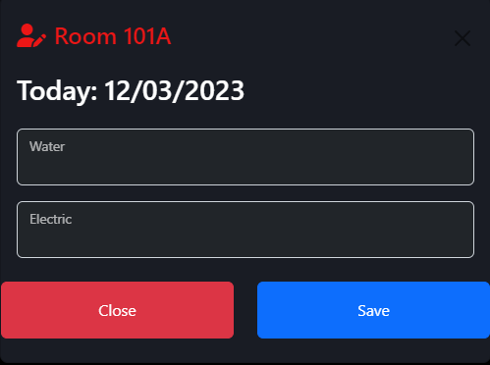

| **UC ID and Name:** | **UC-24. Payment** | | |
| --- | --- | --- | --- |
| **Created By:** | TaiNN | **Date Created:** | 10/03/2023 |
| **Primary Actor:** | Host | **Secondary Actors:** | N/A |
| **Trigger:** | **TRIG-01.** Click to “Electric/Water Icon ” Apartment Room Control | | |
| **Description:** | Host want to calculate total bill | | |
| **Preconditions:** | **PRE-01.** Water number and electricity number needs to be correct according to the date of input | | |
| **Post-conditions:** | Calculate total bill with new water number and electric number for Paying | | |
| **Normal Flow:** | 1. Select “Electric/Water icon ” Apartment Room Control  2. Input “Water number” and “Electric Number” to update  3. Click to button “Save”  4.New “Water number” and Electric Number will update in systems and calculate bill | | |
| **Alternative Flows:** | N/A | | |
| **Exceptions:** | **24.1. User enters a water or electricity number that is smaller than the current number of the previous month** | | |
| **Priority:** | Low | | |
| **Frequency of Use:** | Low | | |
| **Business Rules:** | BR-13 , BR-14 | | |

### 11.3. View Payment

* Function Trigger
  + When Host click to “Unpaid” in Apartment Control
* Function description
  + Actor/Role : Host
  + Purpose : View information off bill
  + Interface :
    - 1 form to View Day Update : Old water number and electric number
    - 1 form to View Day Update : New water number and electric number
    - 4 text file to View Price : Water , Electric , Vehicle , Total
    - 2 button for “Save” and “Close”

| **UC ID and Name:** | **UC-25. Paying** | | |
| --- | --- | --- | --- |
| **Created By:** | TaiNN | **Date Created:** | 10/03/2023 |
| **Primary Actor:** | Host | **Secondary Actors:** | N/A |
| **Trigger:** | **TRIG-01.** Click to “Unpaid ” in Apartment Room Control | | |
| **Description:** | View the total room bill of 1 month | | |
| **Preconditions:** |  | | |
| **Post-conditions:** | View information of electricity, water, room and vehicle to pay for a room | | |
| **Normal Flow:** | 1. Select “Unpaid” Apartment Room Control  2. Display price information for services that need to be paid  3. Click ‘Save’ to confirm Paying | | |
| **Alternative Flows:** | N/A | | |
| **Exceptions:** | N/A | | |
| **Priority:** | Low | | |
| **Frequency of Use:** | Low | | |
| **Business Rules:** |  | | |

### 11.4. Bill

* Function Trigger
  + When Host click to “Confirm” button
* Function description
  + Actor/Role : Host
  + Purpose : Confirm the invoice has been paid
  + Interface :
    - 1 form to View Day Update : Old water number and electric number
    - 1 form to View Day Update : New water number and electric number
    - 4 text file to View Price : Water , Electric , Vehicle , Total
    - 2 button for “Save” and “Close”

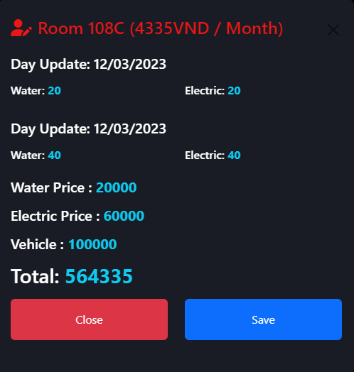

| **UC ID and Name:** | **UC-25. Paying** | | |
| --- | --- | --- | --- |
| **Created By:** | TaiNN | **Date Created:** | 10/03/2023 |
| **Primary Actor:** | Host | **Secondary Actors:** | N/A |
| **Trigger:** | **TRIG-01.** Click to “Confirm” in Apartment Room Control | | |
| **Description:** | Confirm that the bill has been paid by the tenant for this month | | |
| **Preconditions:** | Payment status must going to Paying | | |
| **Post-conditions:** | Payment status will be change to “Paid” | | |
| **Normal Flow:** | 1. Select “Confirm” Apartment Room Control  2. Display information off Bill  3. Click ‘Save’ to confirm Paied | | |
| **Alternative Flows:** | N/A | | |
| **Exceptions:** | N/A | | |
| **Priority:** | Low | | |
| **Frequency of Use:** | Low | | |
| **Business Rules:** |  | | |

# III. Requirement Appendix

## 1. Business Rule

| **ID** | **Rule definition** |
| --- | --- |
| BR-01 | The user must provide a phone number and password to login. |
| BR-02 | The date will be displayed in the format: dd/mm/yyyy. |
| BR-03 | The time will be displayed in 24-hour time. |
| BR-04 | The password must have at least 8 characters and alphanumeric. |
| BR-5 | Registering an account requires an email, password. |
| BR-6 | User must login |
| BR-7 | In create/edit form Date of birth of user must not greater than current date |
| BR-8 | Description cannot exceed 50 characters |
| BR-9 | Each Floor has an unique id |
| BR-10 | Each Tenant has an unique id |
| BR-11 | Floor Name has an unique |
| BR-12 | Must be able to locate |
| BR-13 | User enters a water or electricity number that is smaller than the current number of the previous month |
| BR-14 | water or electricity number must be a number digit |
|  |  |

## 

## 

## 

## 

## 2. Message List

| **#** | **ID** | **Message Type** | **Context** | **Content** |
| --- | --- | --- | --- | --- |
| 1 | MSG01 | In red, under text field | Login with wrong email or password | Email hoặc mật khẩu không hợp lệ |
| 2 | MSG02 | In red, under text field | Input required fields are empty | ${Tên_trường} không được bỏ trống |
| 3 | MSG03 | In red, under text field | Invalid Email Validation Code | Mã xác nhận email không hợp lệ |
| 4 | MSG04 | In red, under text field | Wrong email format | Email không hợp lệ |
| 5 | MSG05 | Toast message | Phone number is existed in the system | Email này đã tồn tại trong hệ thống |
| 6 | MSG06 | Toast message | Unmatched password | Mật khẩu không khớp |
| 7 | MSG07 | In red, under text field | New password must differ than old password | Mật khẩu mới không được trùng với mật khẩu cũ |
| 8 | MSG08 | Toast message | Confirm that verify information success | Xác nhận thông tin thành công |
| 9 | MSG09 | In grey, centre of the screen | When the user or nutrition expert does not enter the search information, or there are no results returned | Không tìm thấy kết quả |
| 10 | MSG10 | In red, under text field | The user inputs wrong password format | Mật khẩu phải chứa ít nhất 8 ký tự |
| 11 | MSG11 | Toast message | Register successfully | Đăng ký thành công |
| 12 | MSG12 | Toast message | Change password successfully | Đổi mật khẩu thành công |
| 13 | MSG13 | In Grey, center of the screen | When search return empty | Kết quả tìm kiếm đang trống |
| 14 | MSG14 | In Red, under text field | There already a name like this exists in the system | Đã tồn tại ${STRING} với tên này |
|  |  |  |  |  |

## 